**SQL Assignments**

Fletcher Robson

Ferris State University

ISIN 325

Dr. Greg Gogolin

September 26, 2024

Table of Contents

**SQL Assignment 1 3**

Screenshots: 3

**SQL Assignment 2 15**

Screenshots: 15

**SQL Assignment 3 24**

# SQL Assignment 1

## Screenshots:

1. 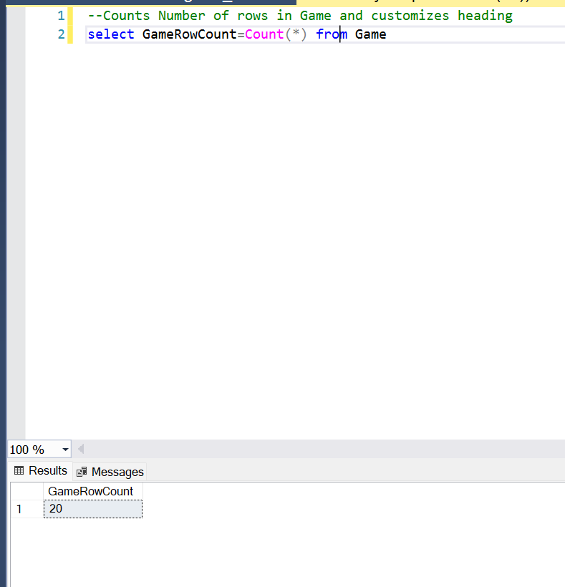
2. 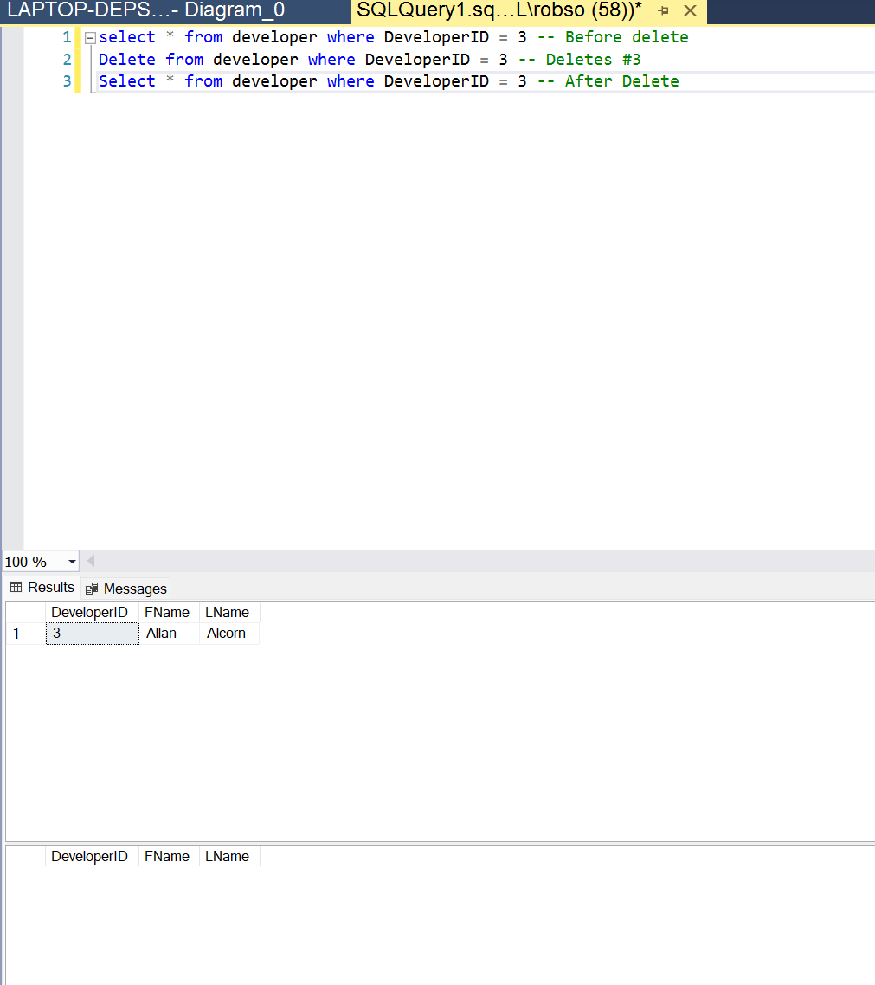
3. 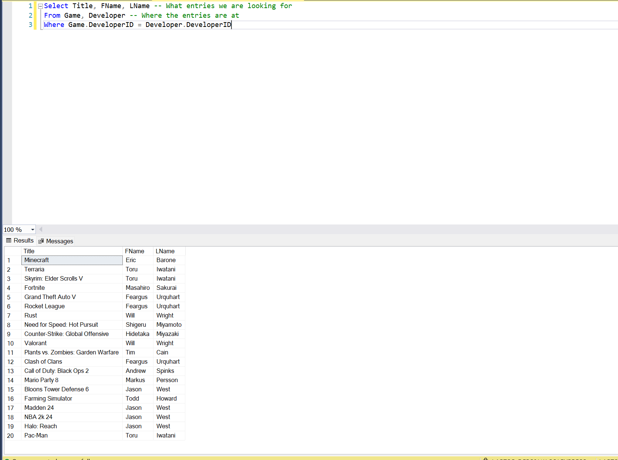
4. 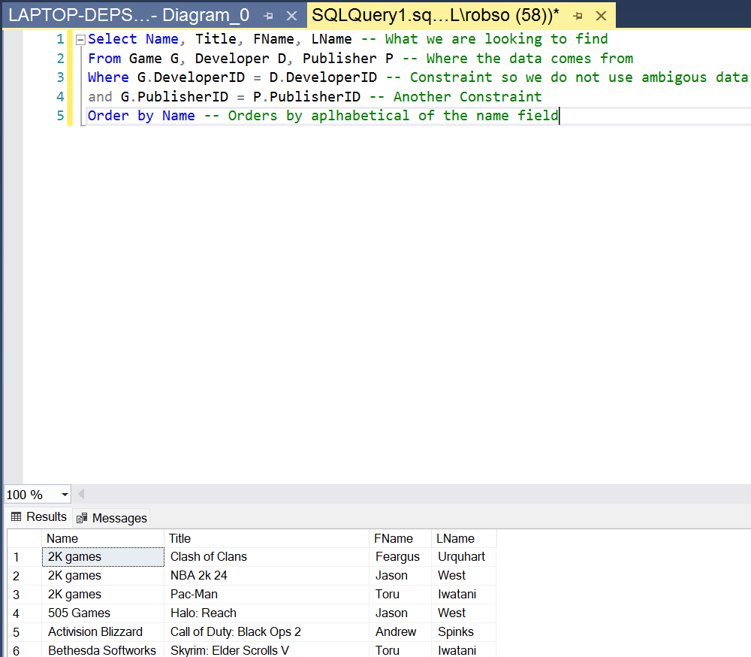
5. 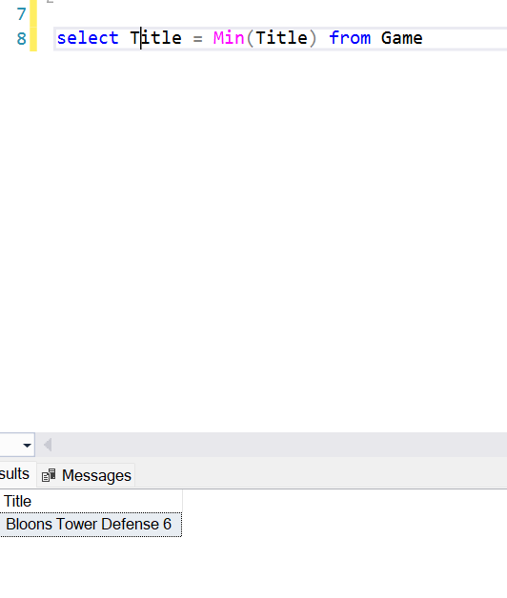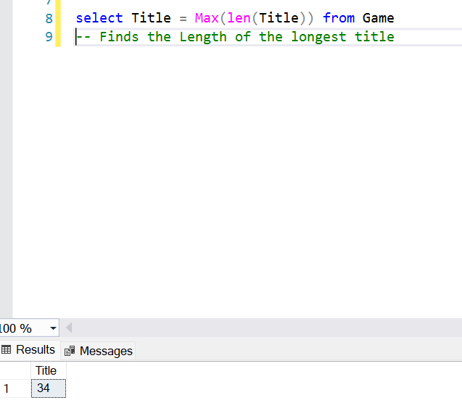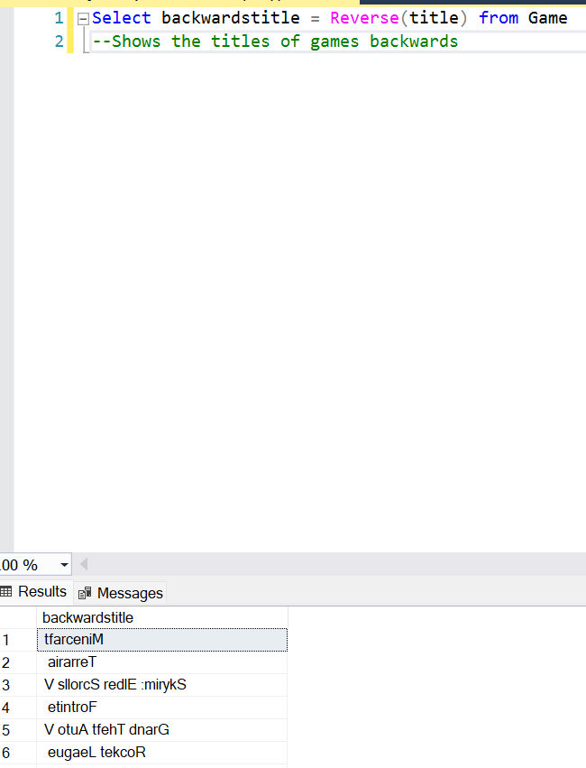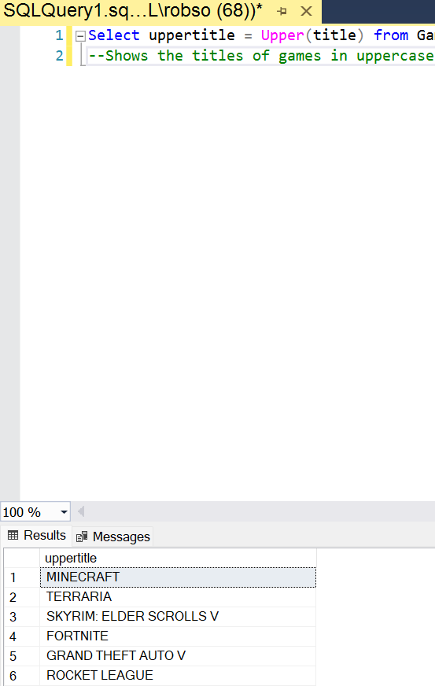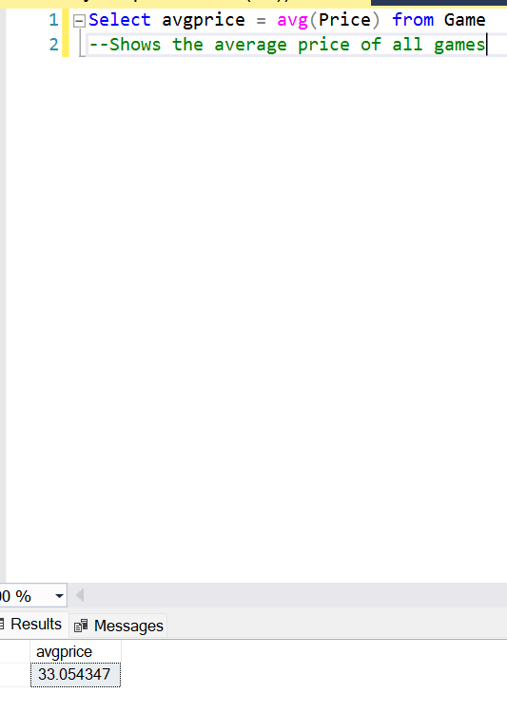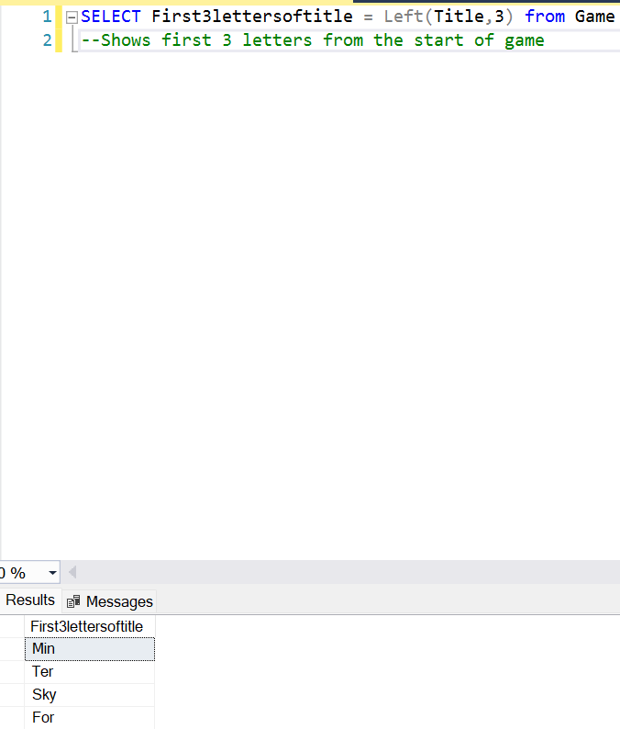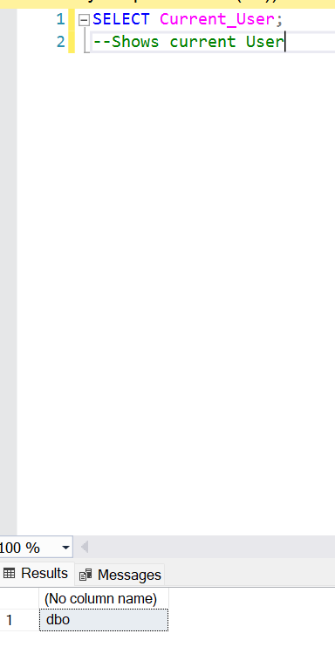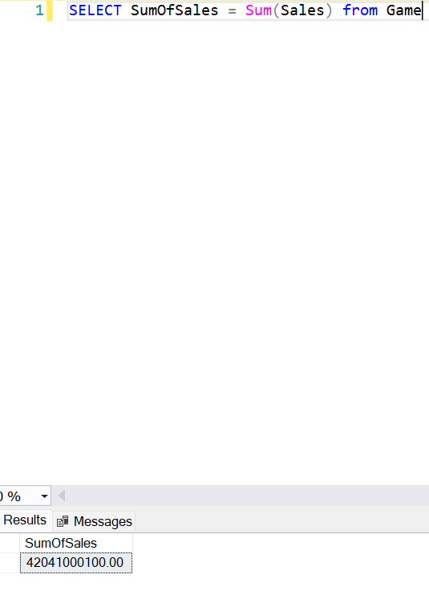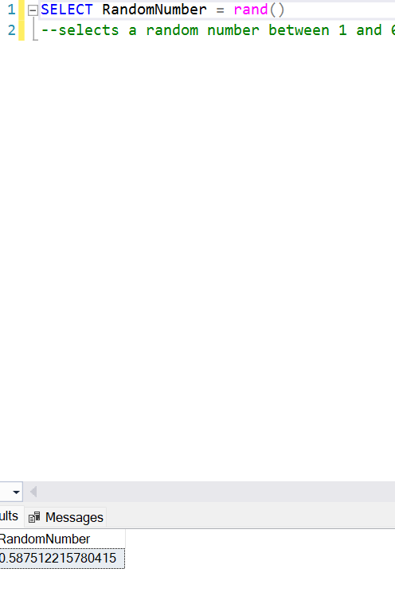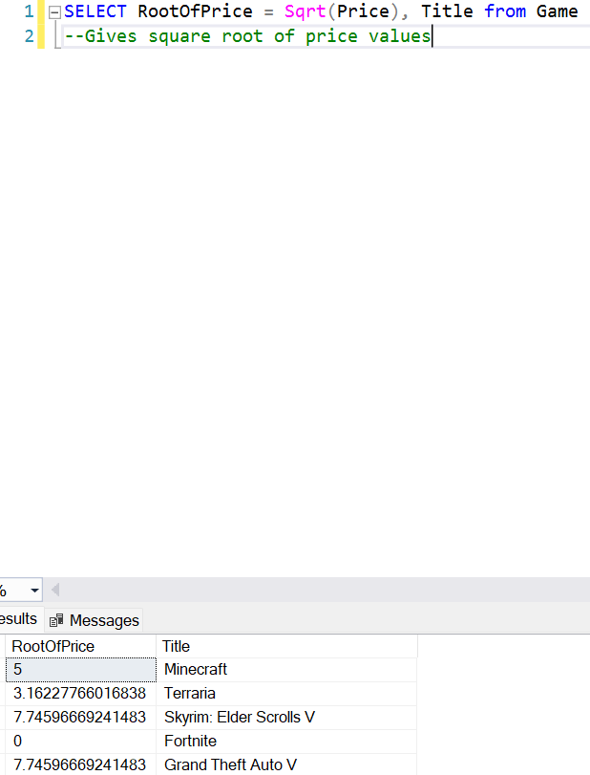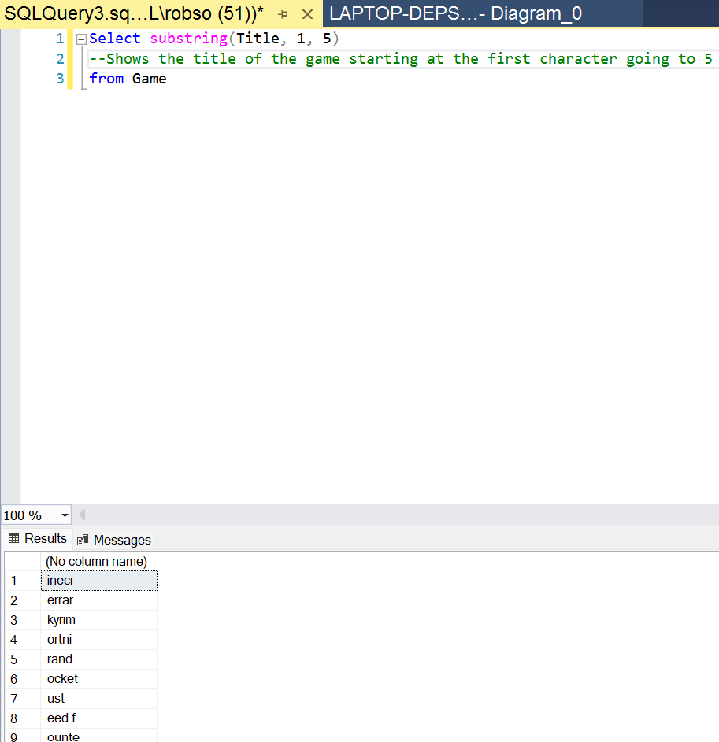
6. 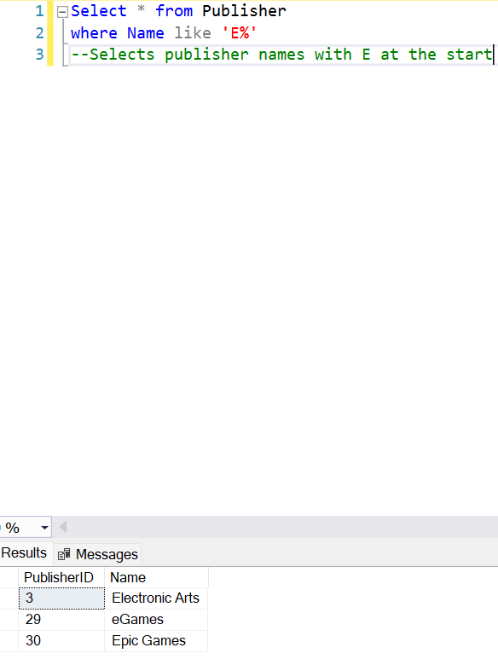
7. 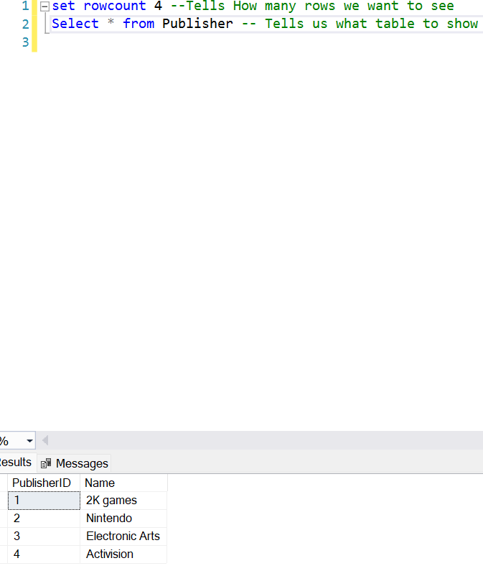
8. 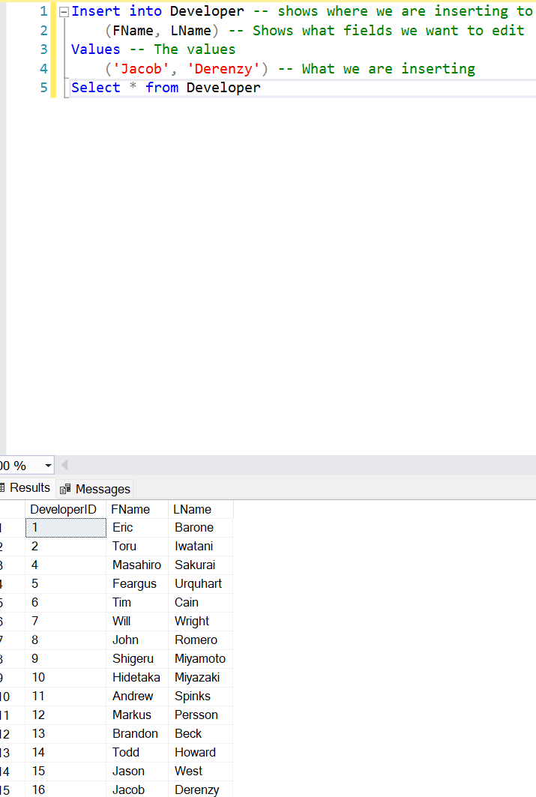
9. No Middle Name Field
10. 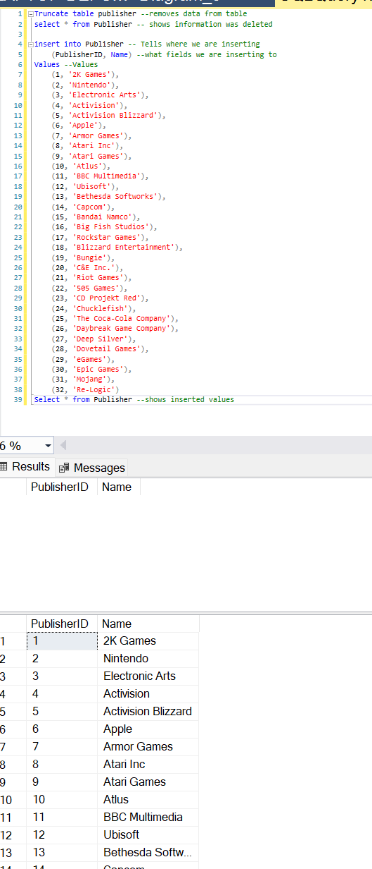
11. 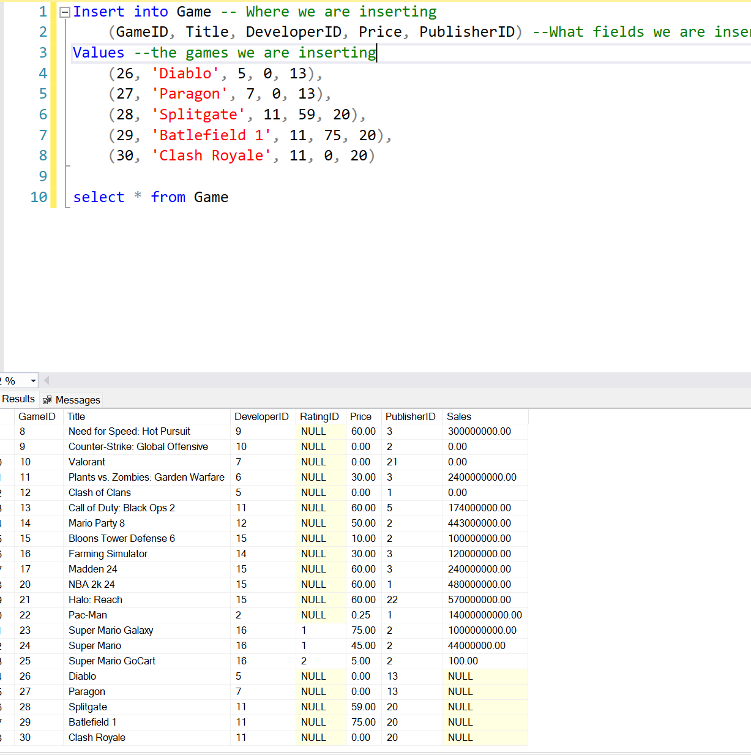
12. 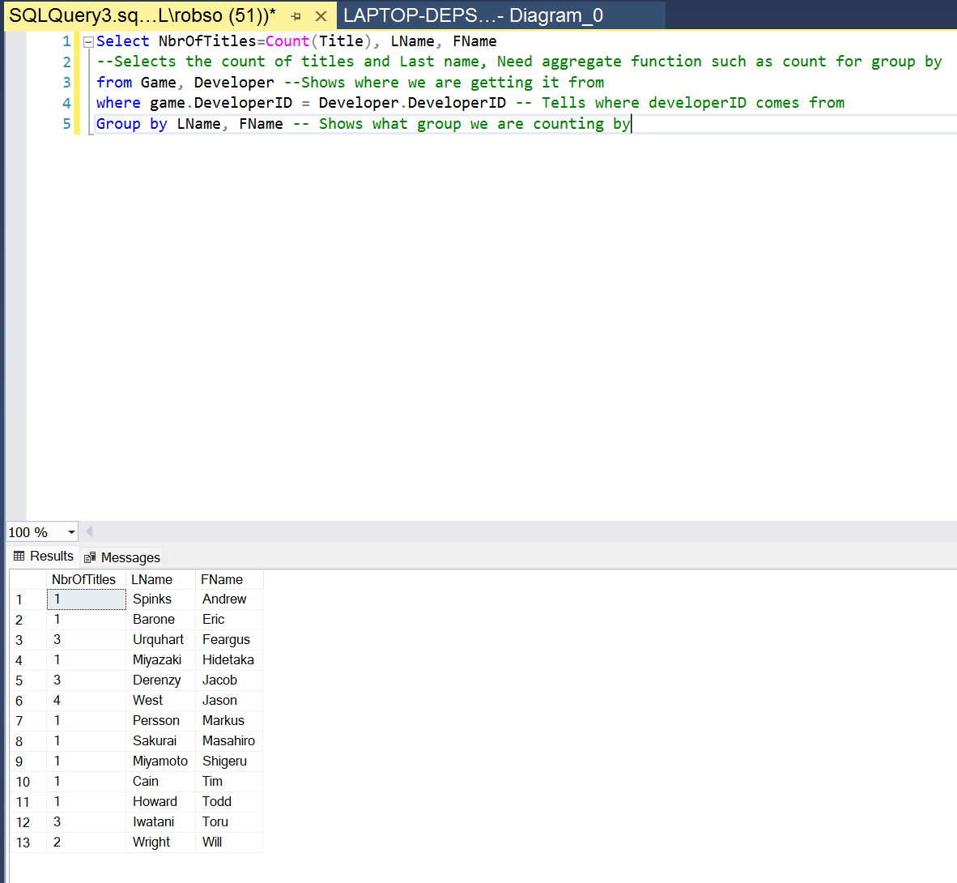
13. 
14. 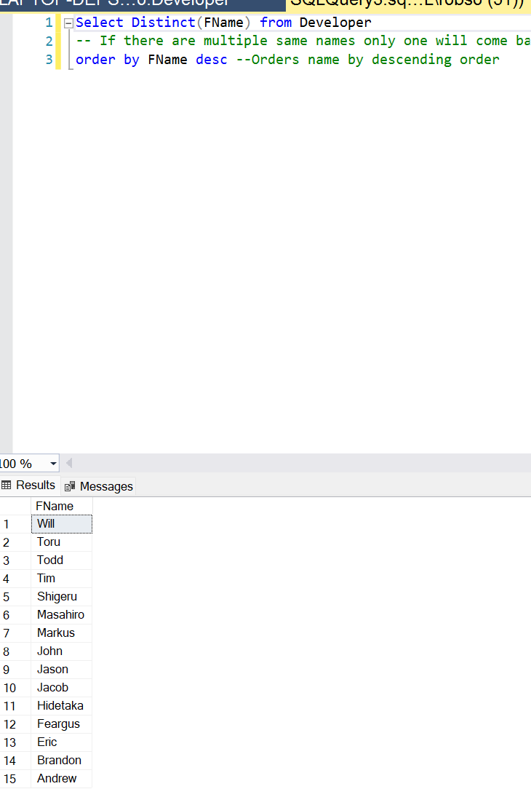
15. 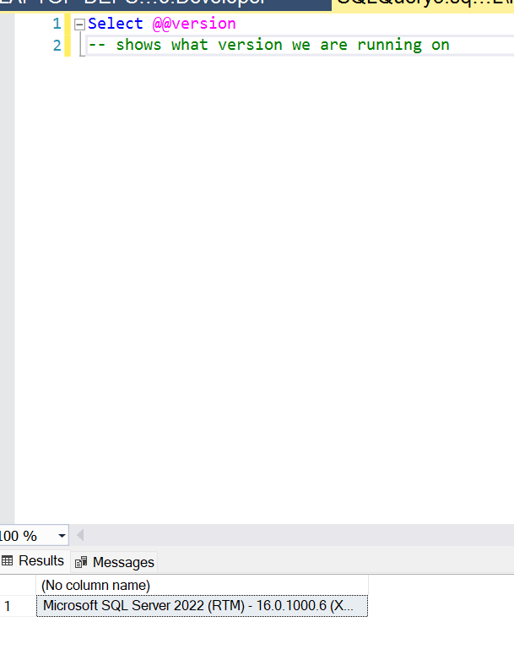
16. 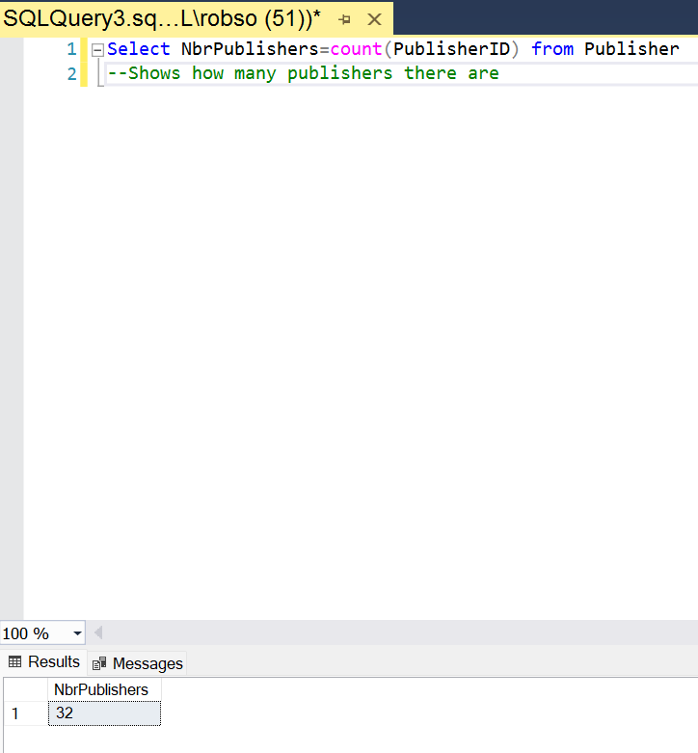
17. No Question
18. 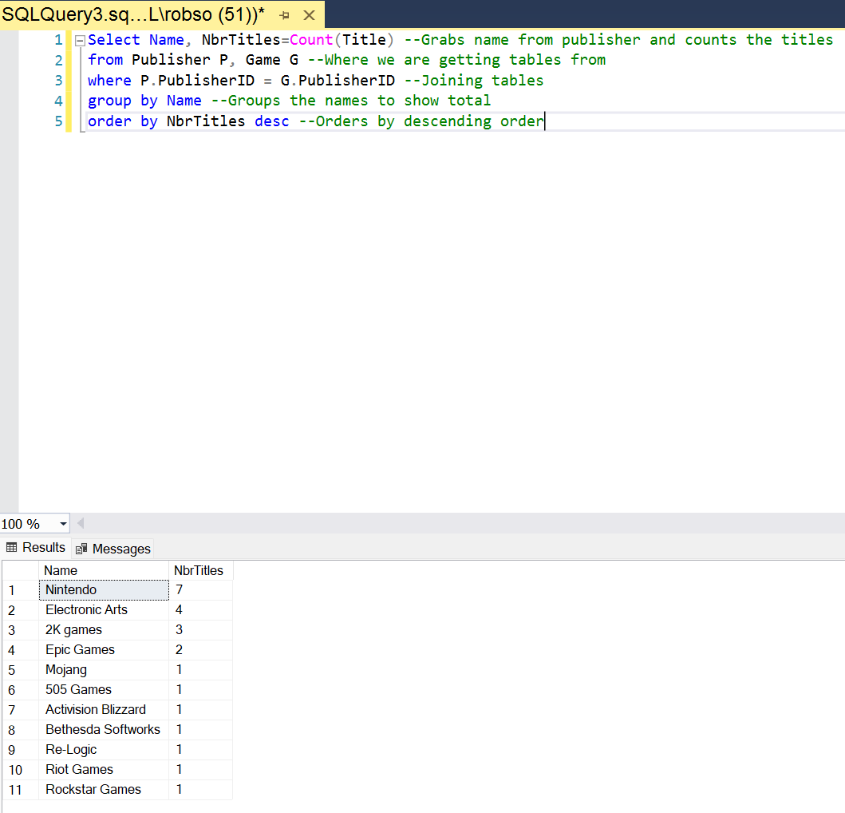
19. 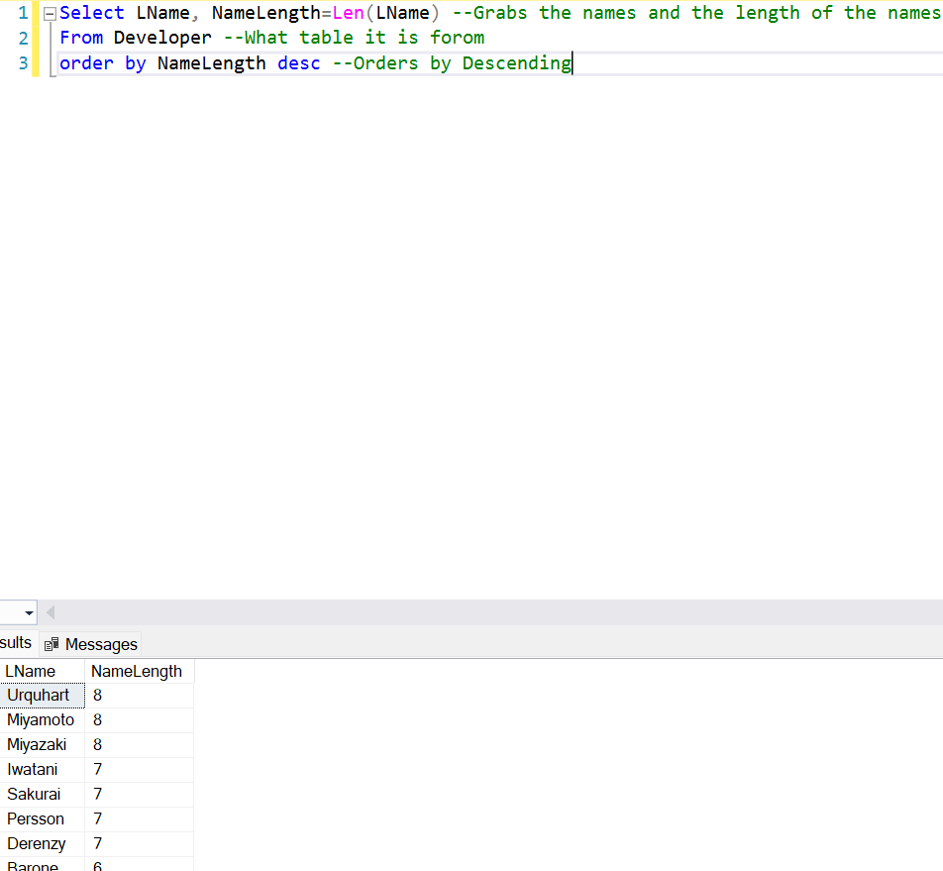
20. 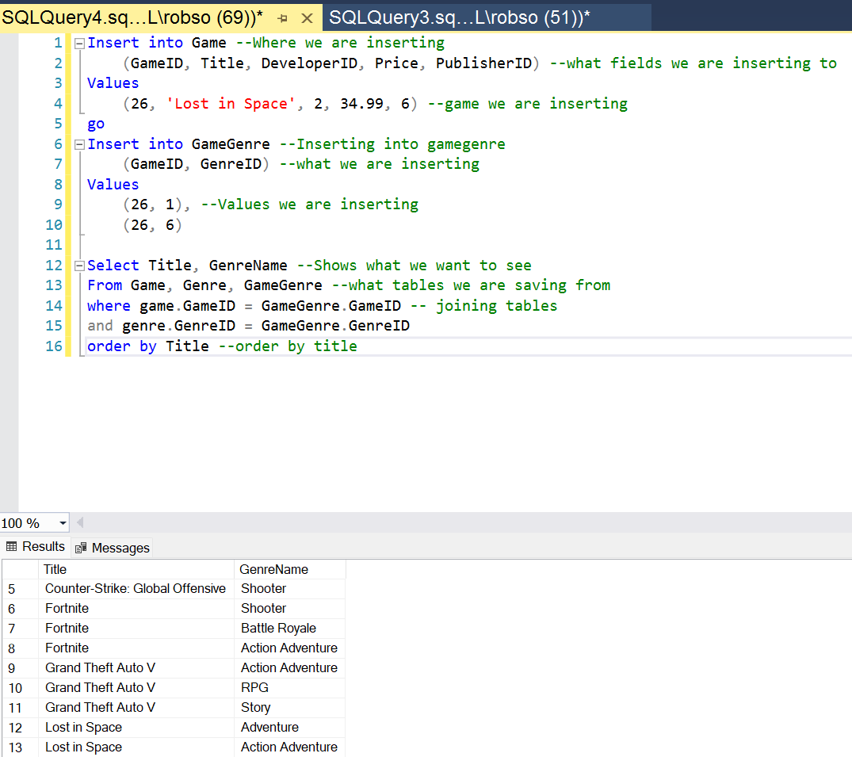

# 

# SQL Assignment 2

## Screenshots:

1. 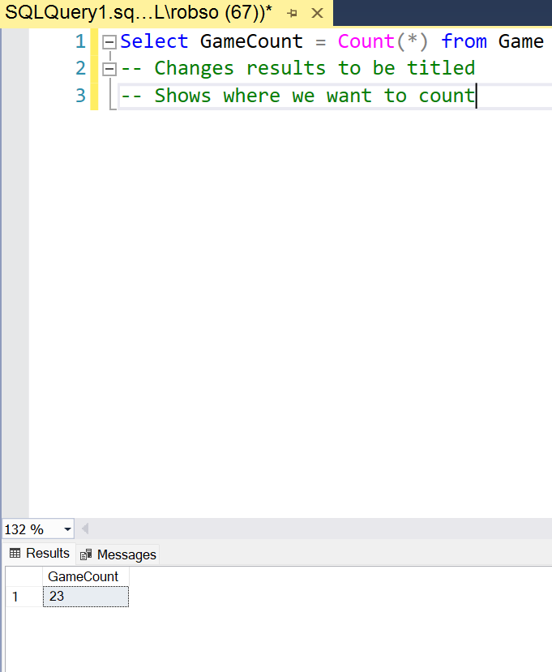
2. 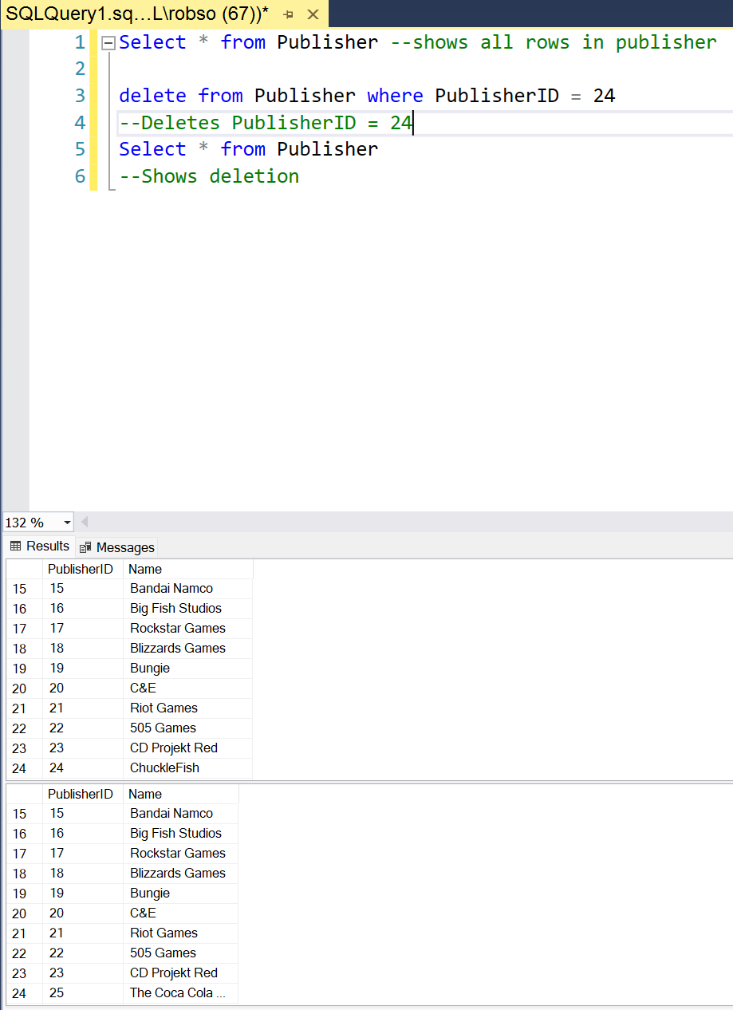
3. 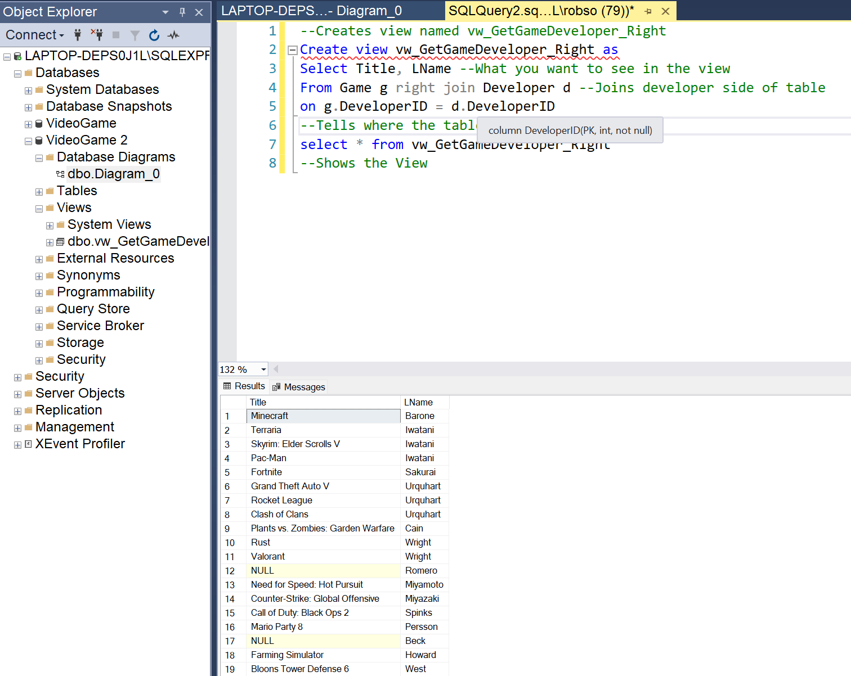
4. 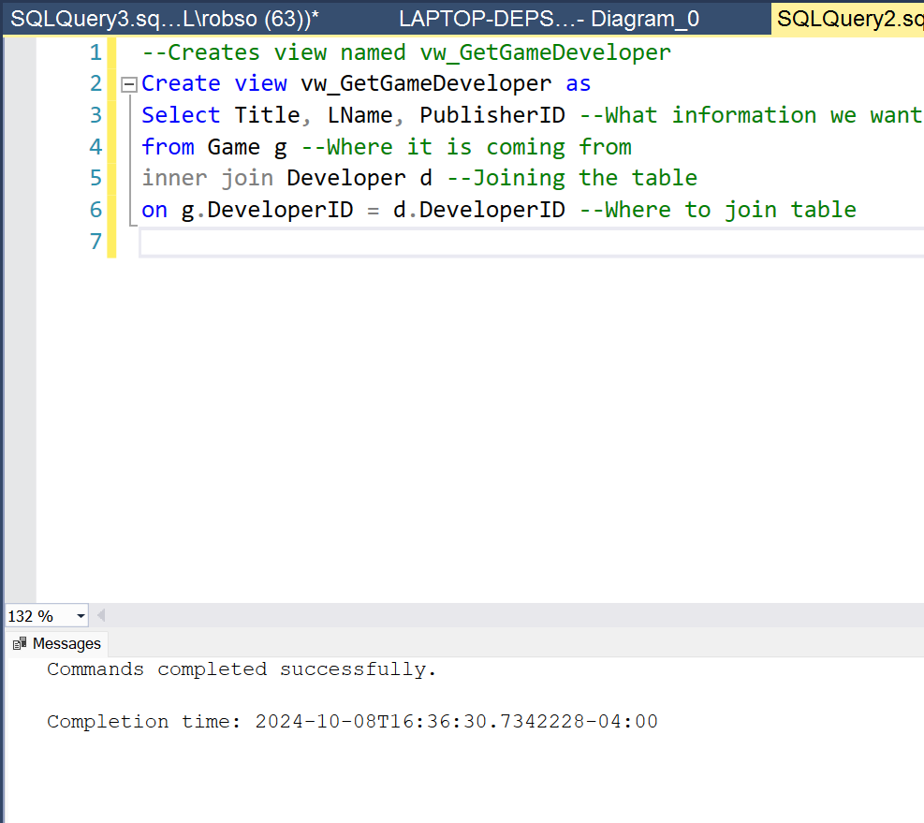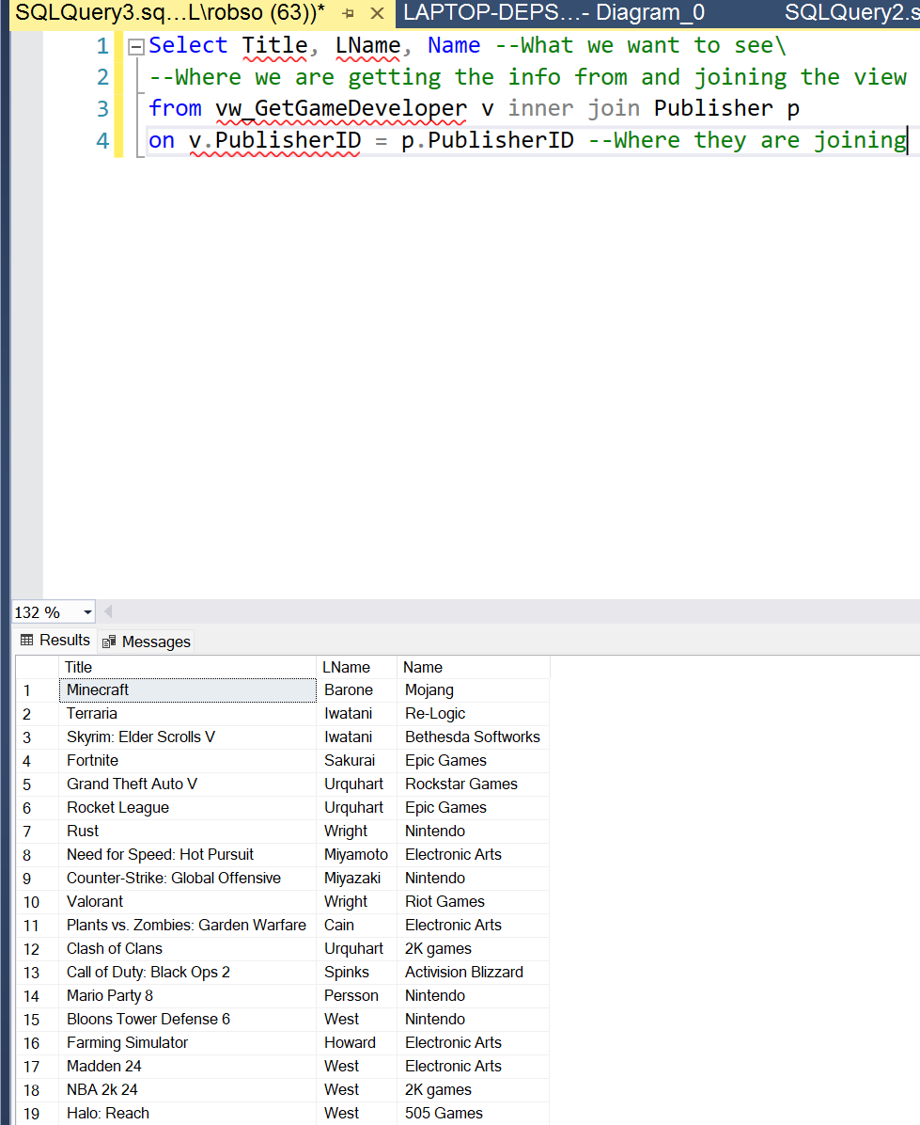
5. 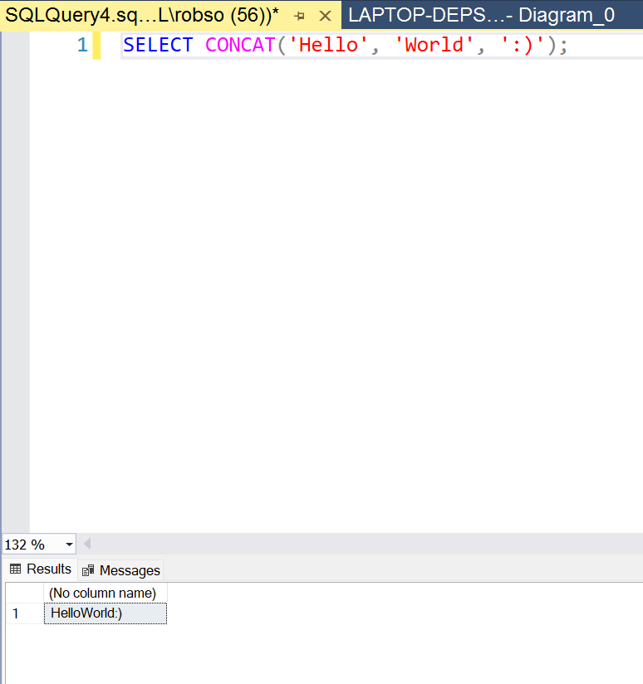 – Adds string together 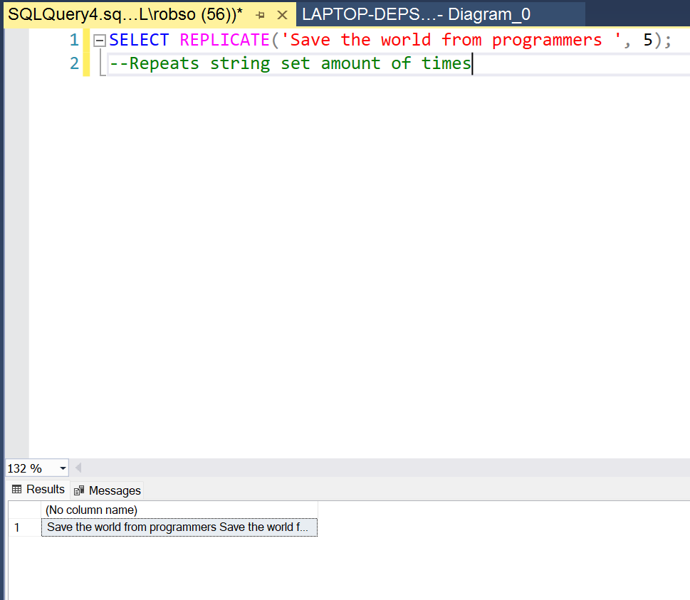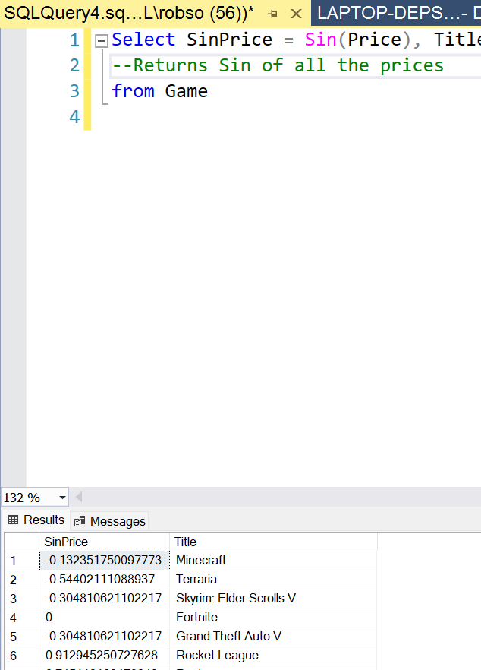 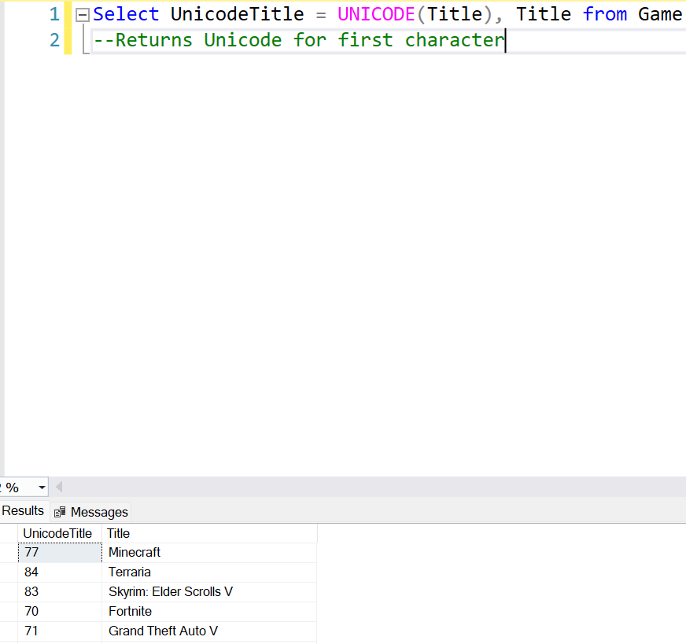  
   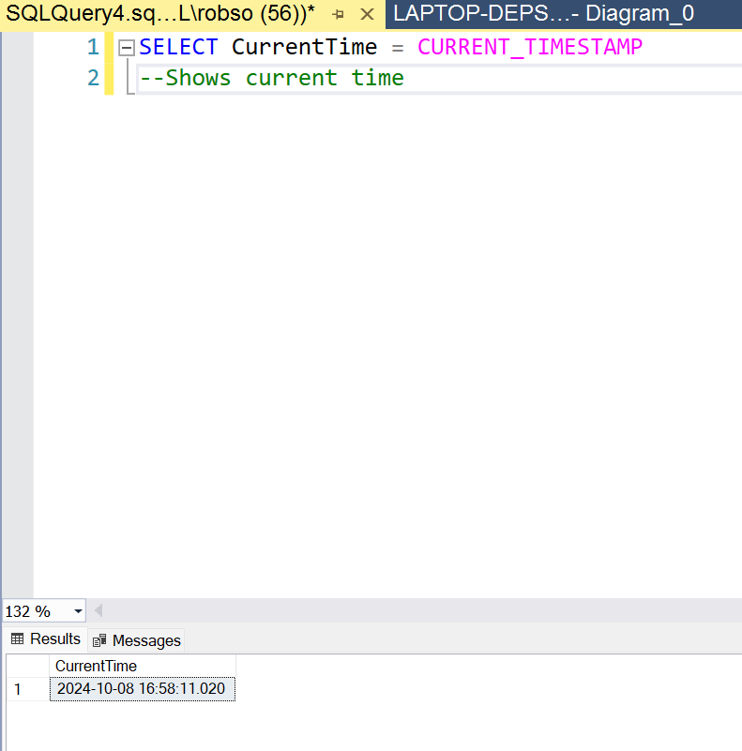
6. 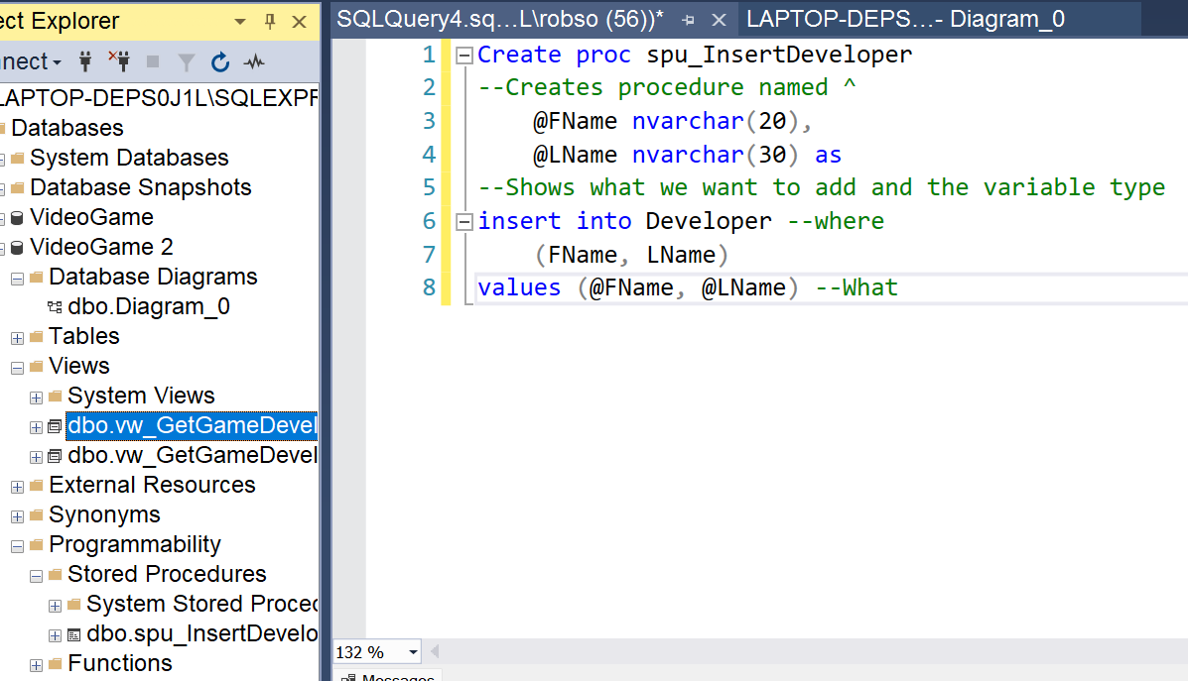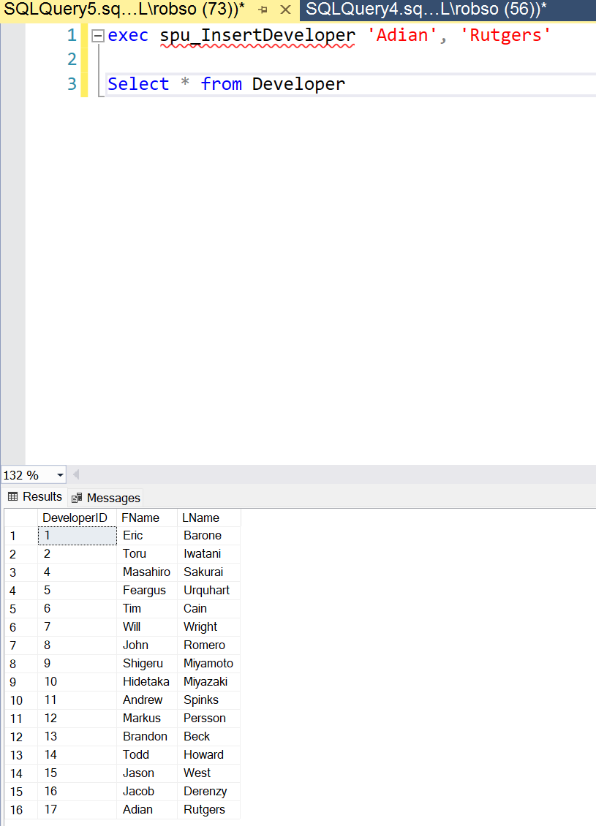
7. 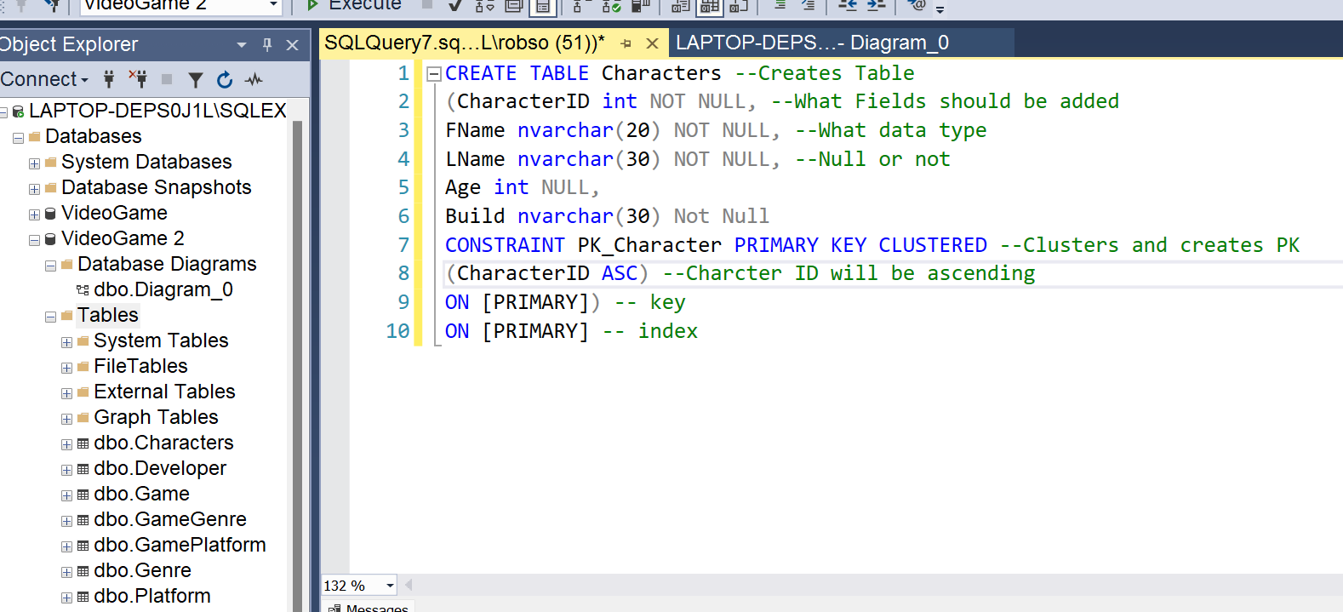
8. 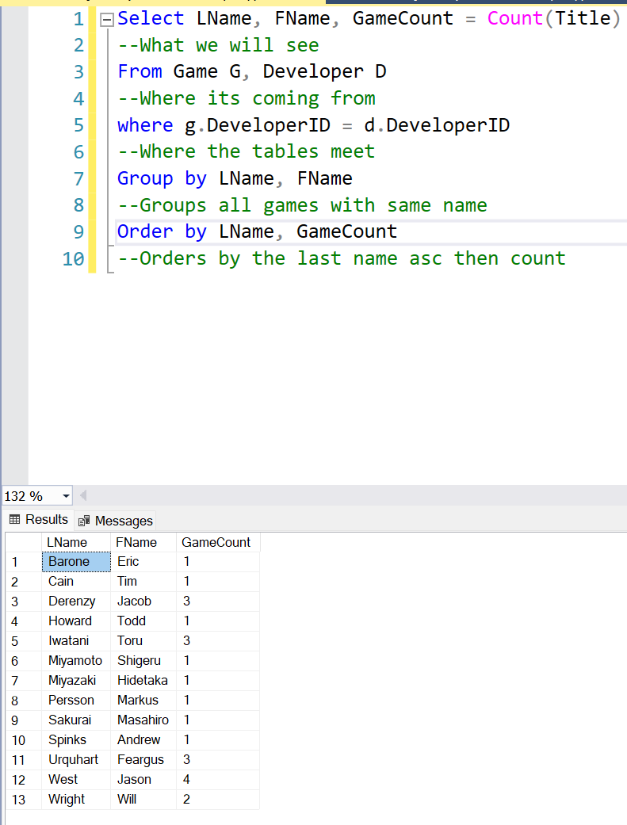
9. 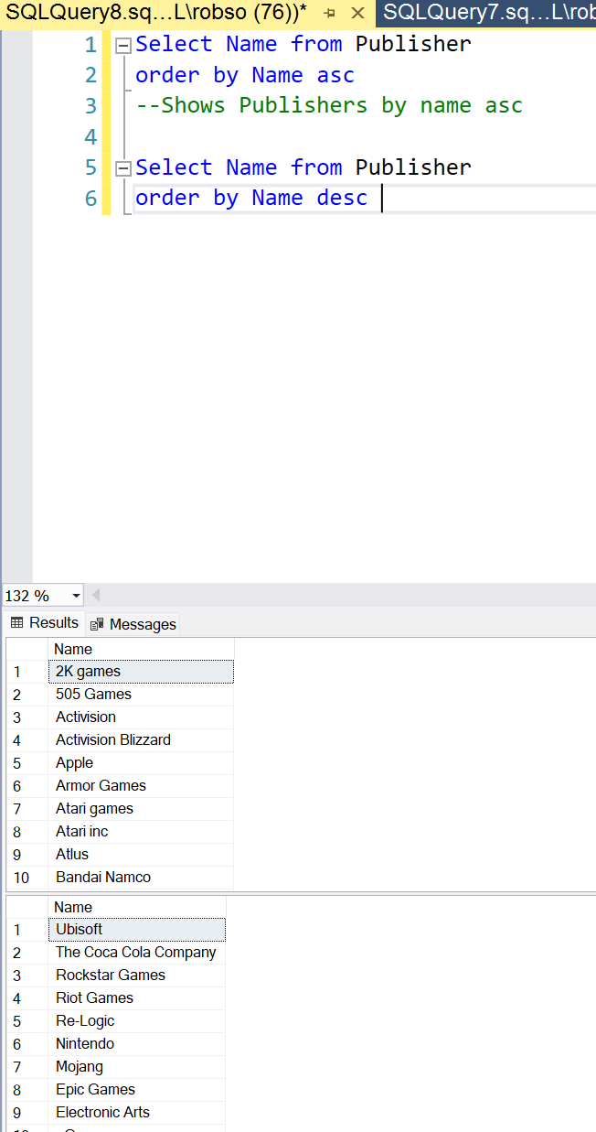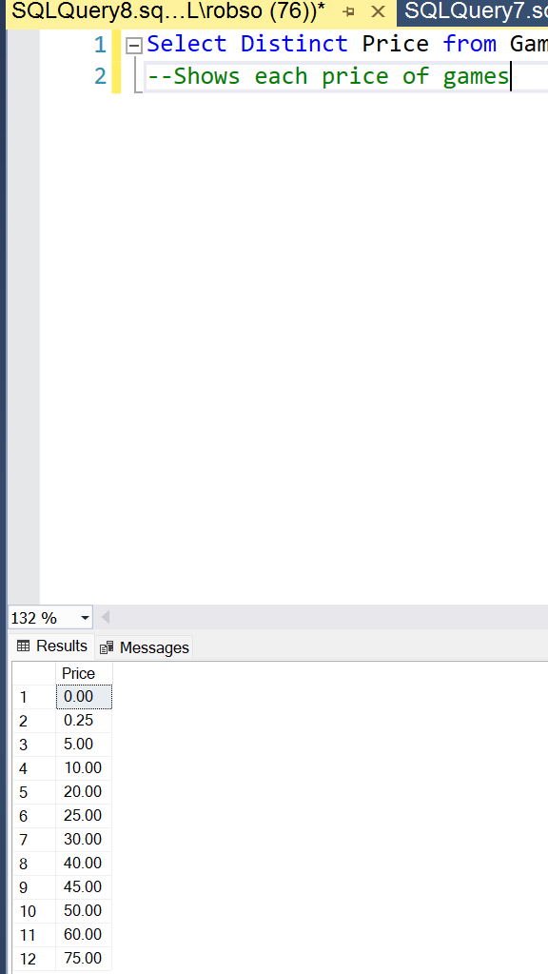
10. 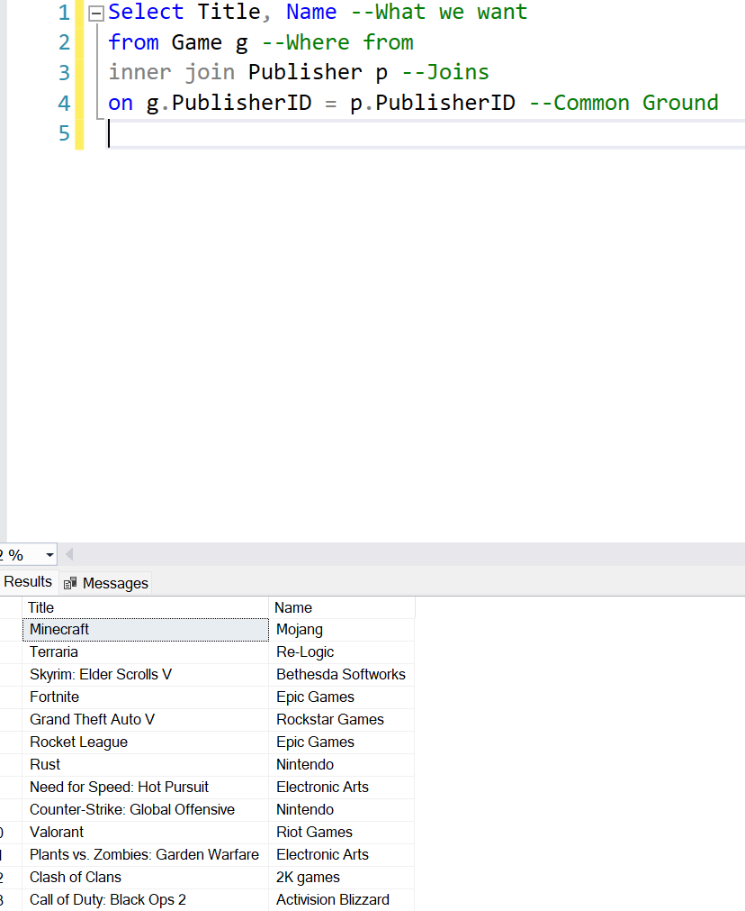
11. 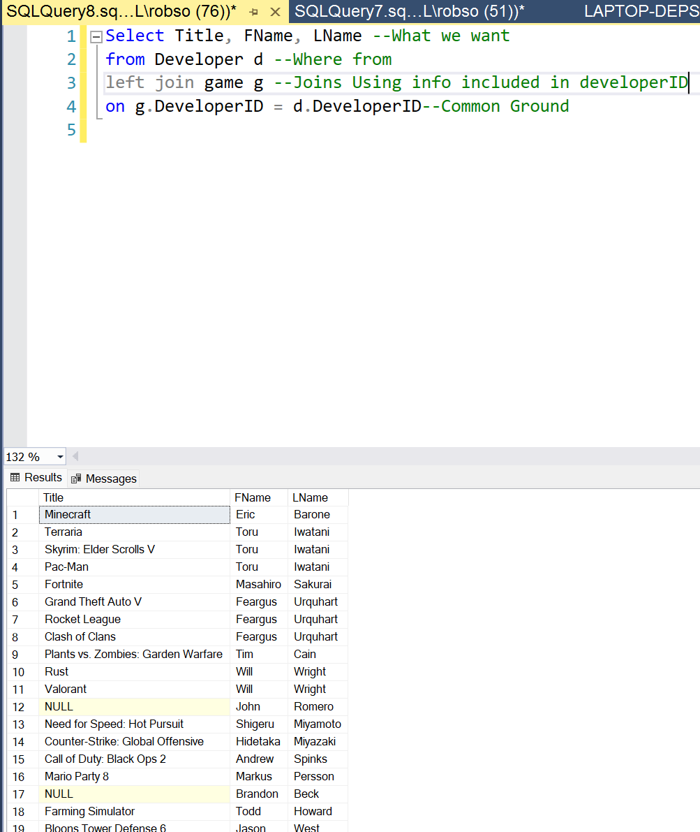
12. 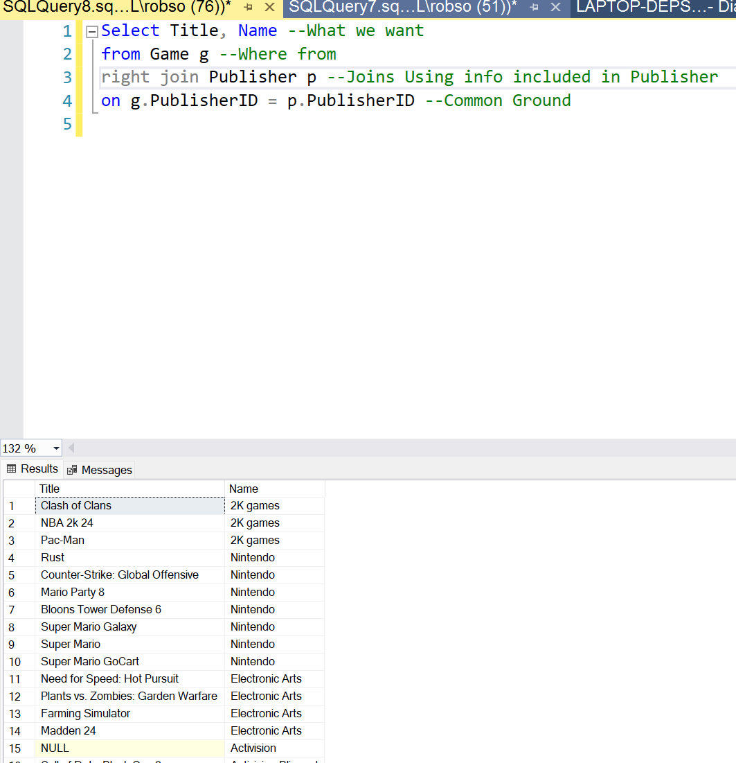

# 

# 

# 

# 

# 

# SQL Assignment 3

**FORGOT IN TEXT DOCUMENTATION WILL PROVIDE IN THE DOC**

1. 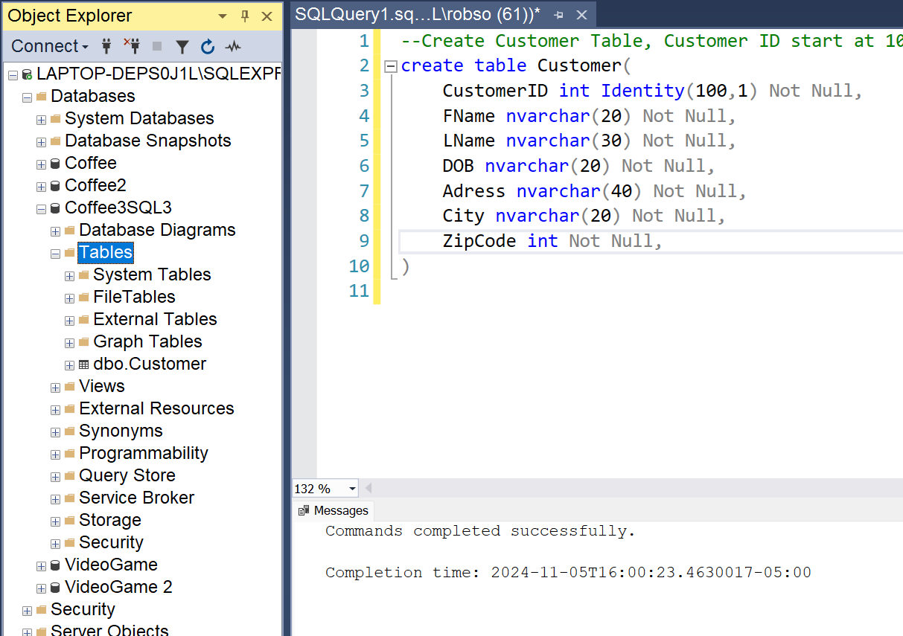
   1. First Creates Customer Table
   2. Creates CustomerID as an int Identity that starts at 100 and increases by 1
   3. Adds all other Columns in table
2. 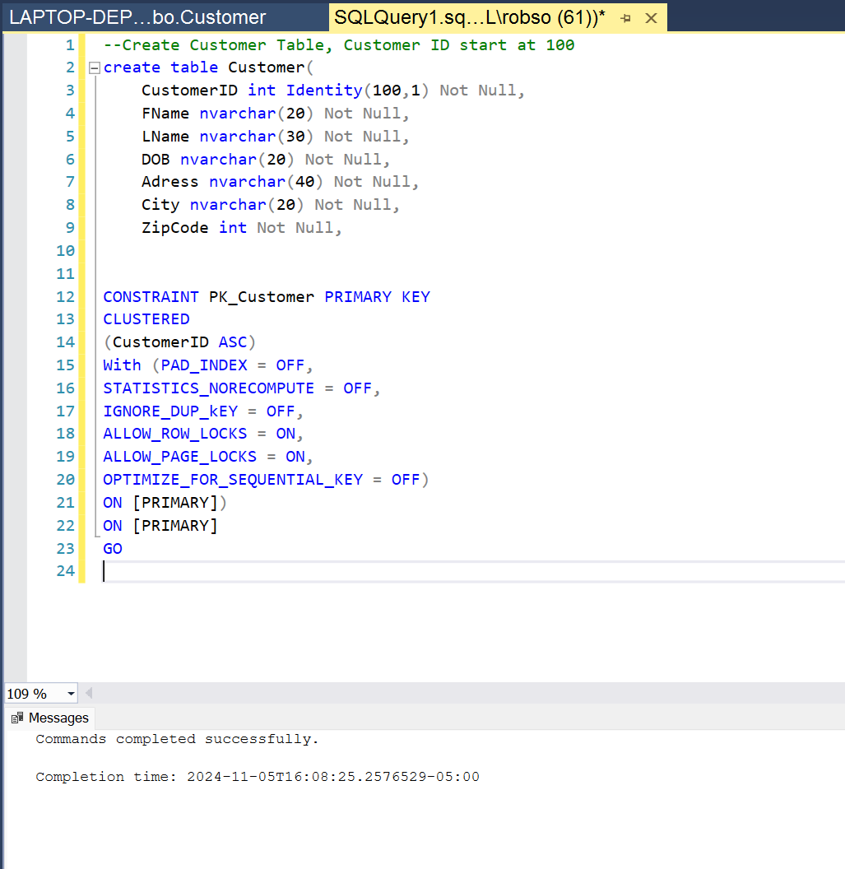
   1. Creates the Primary Key for customer table
   2. Makes it a clustered key
   3. Makes CustomerID the key and sorts it ascending
   4. Ignore_Dup_Key On allows for duplicate entries without an error
3. 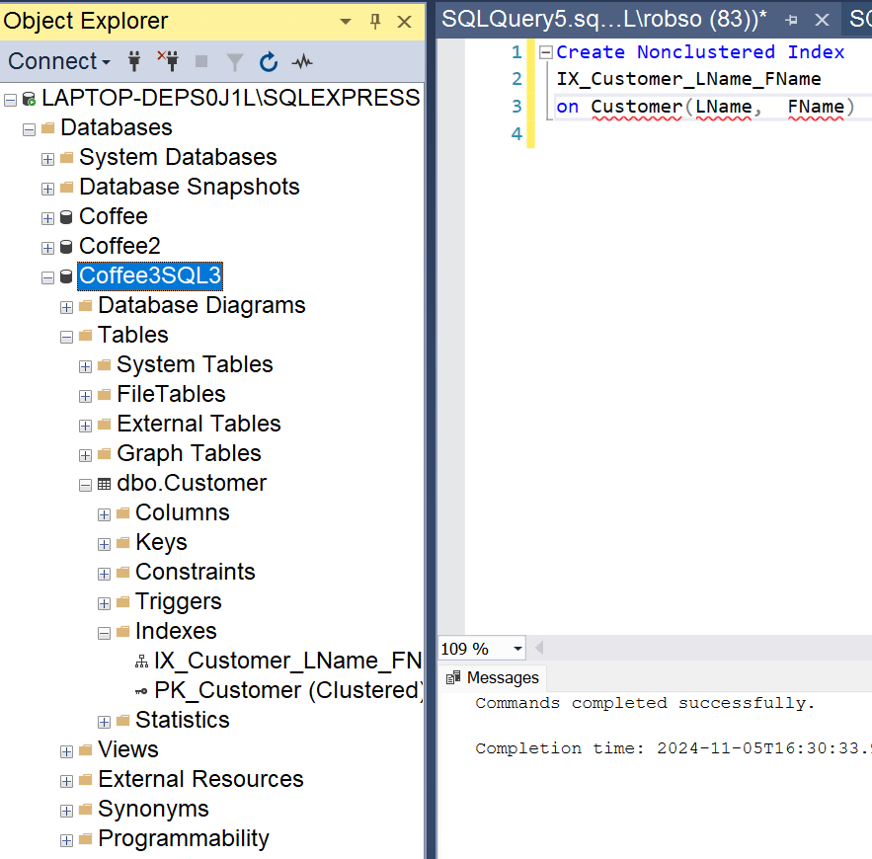
   1. Creates non-Clustered index
   2. Names index
   3. What table and what columns are used in the index
4. 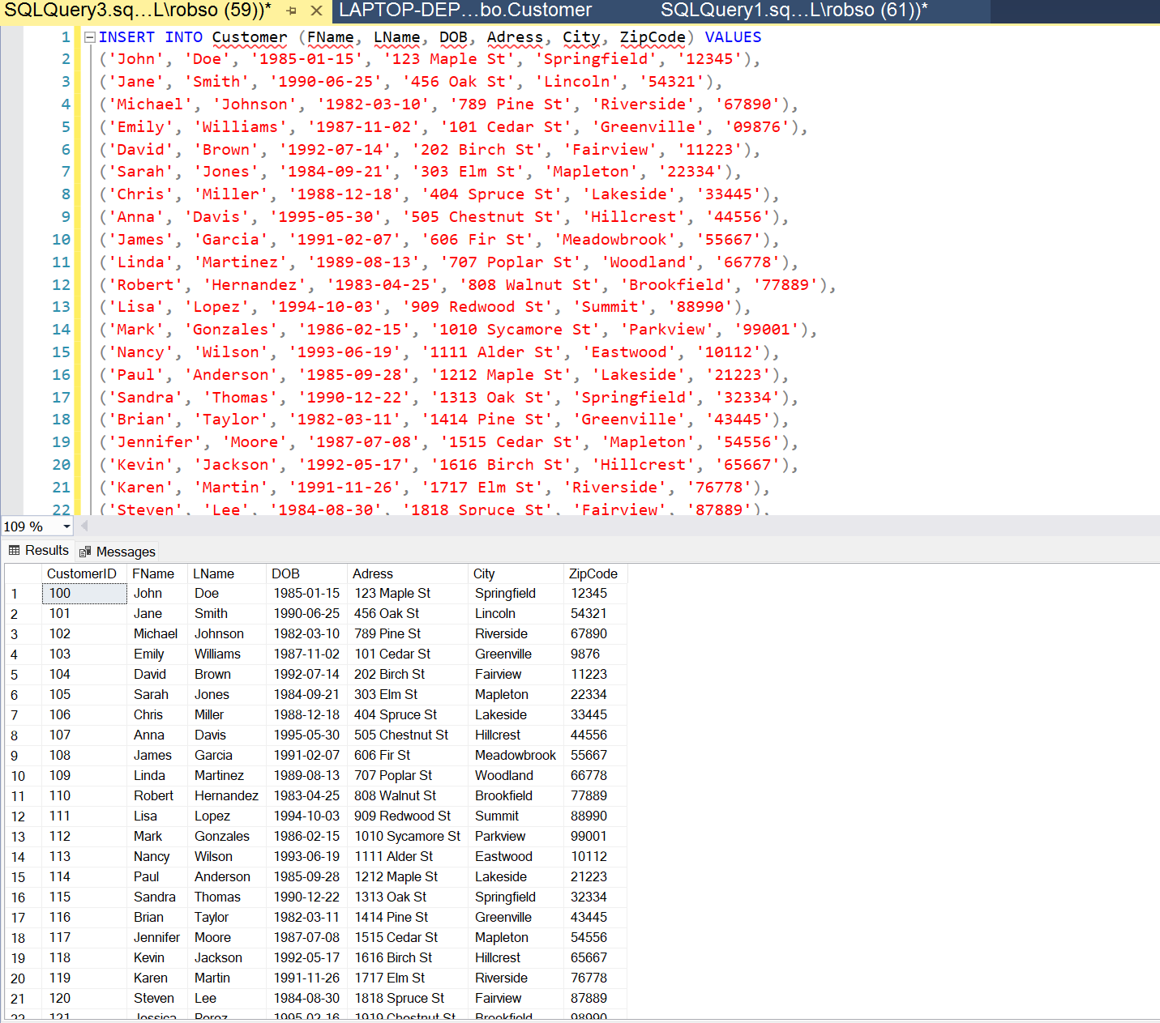
   1. Tells what table we are inserting to and what variables
   2. Gives the values we are inserting
5. 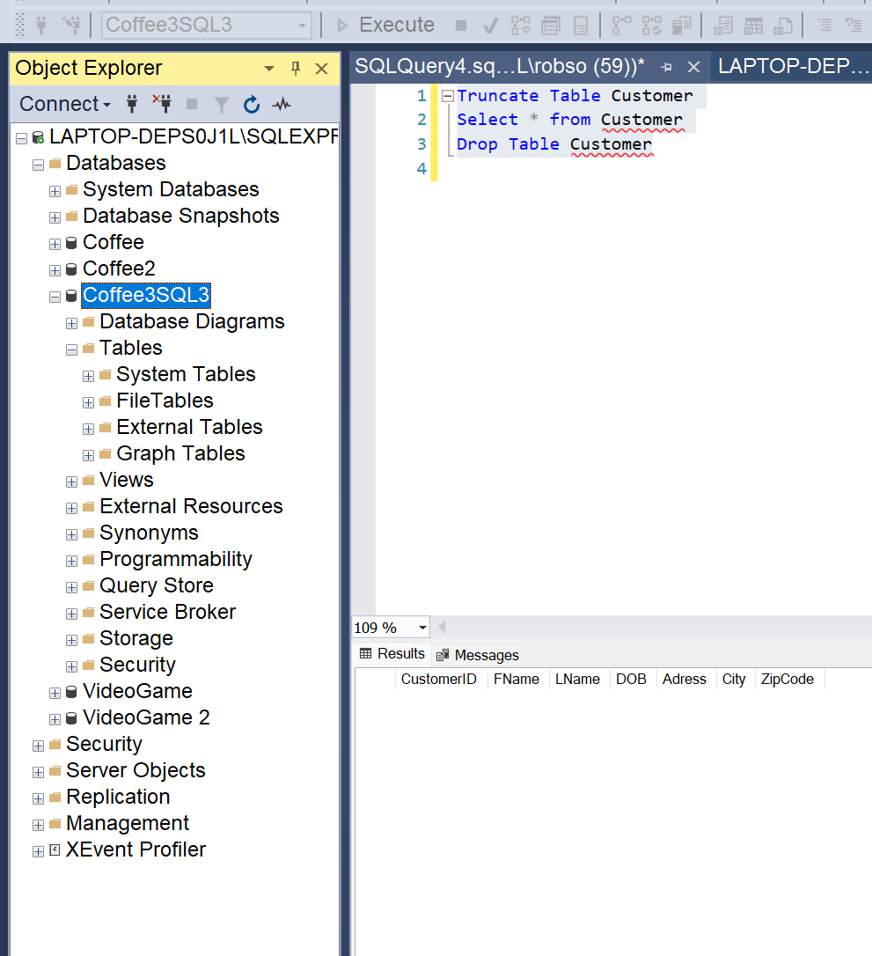
   1. Truncates table,
   2. Shows it was truncated
   3. Drops table
6. 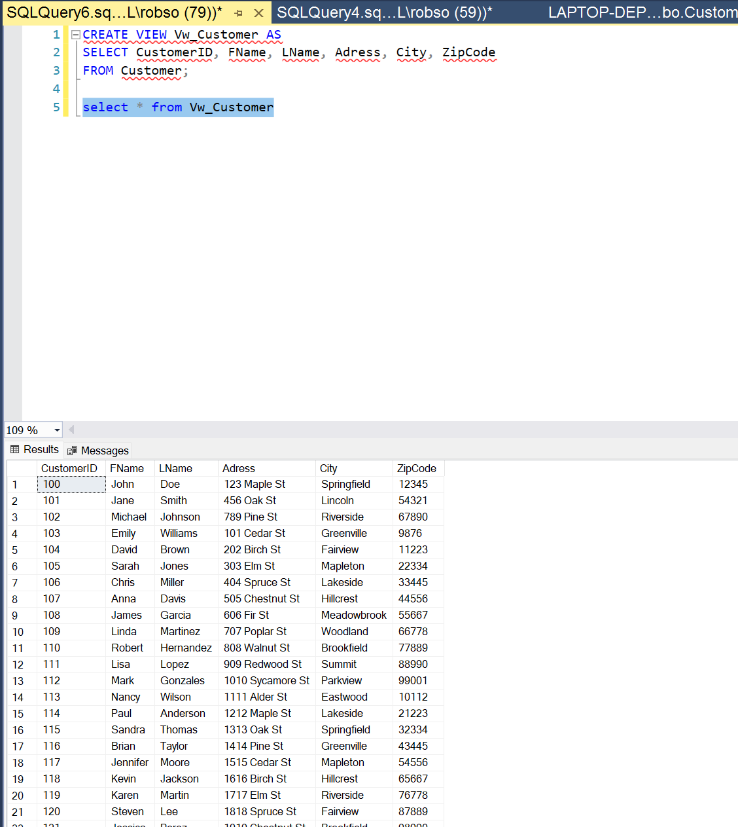
   1. Creates view and names it
   2. Gives the columns we are looking to see
   3. From what table
7. 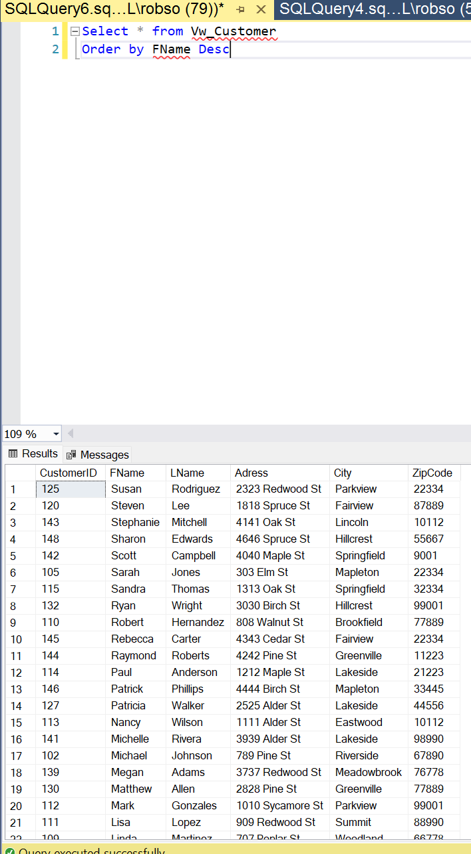
   1. Opens the view
   2. Orders it by First Name in descending order
8. 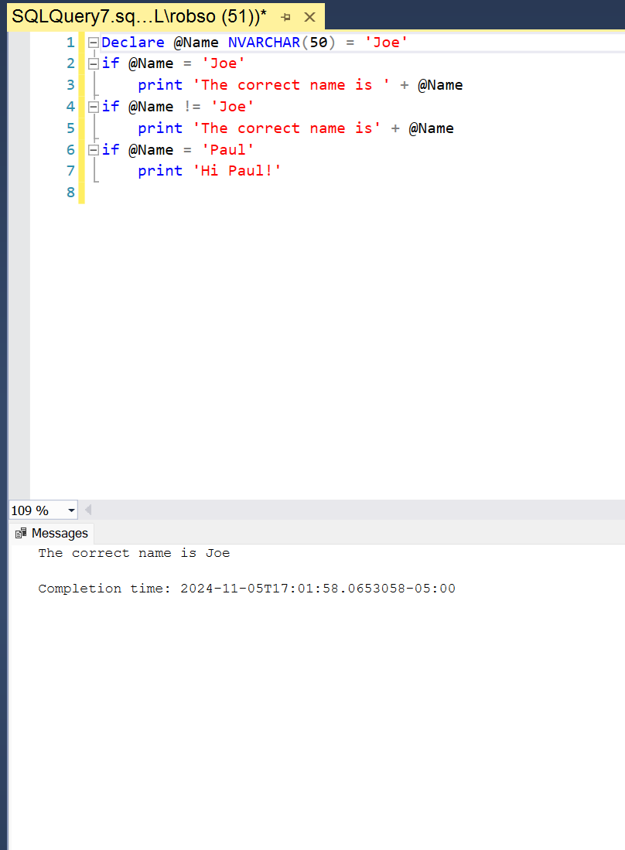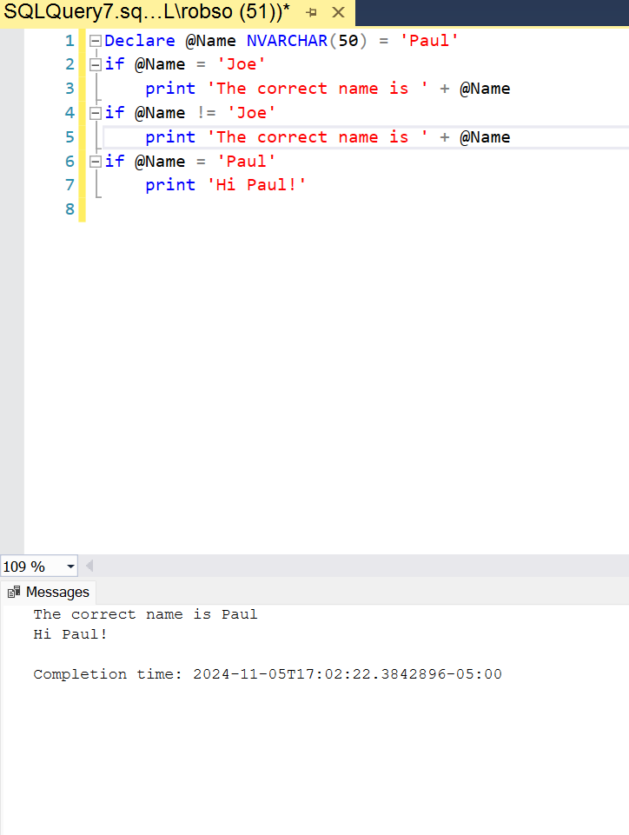
   1. Declares @Name as Joe
   2. If the name is joe then print:
   3. If the name is not joe then print:
   4. If the name is paul then print:
9. 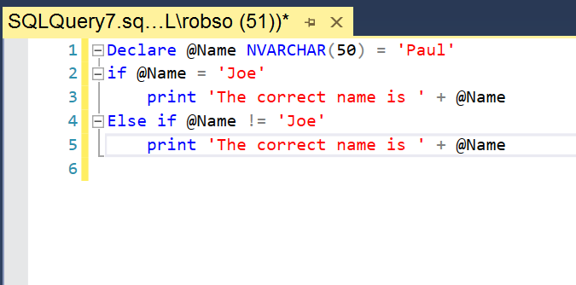
   1. Declares name is paul
   2. If the name is joe print:
   3. Else print:
10. 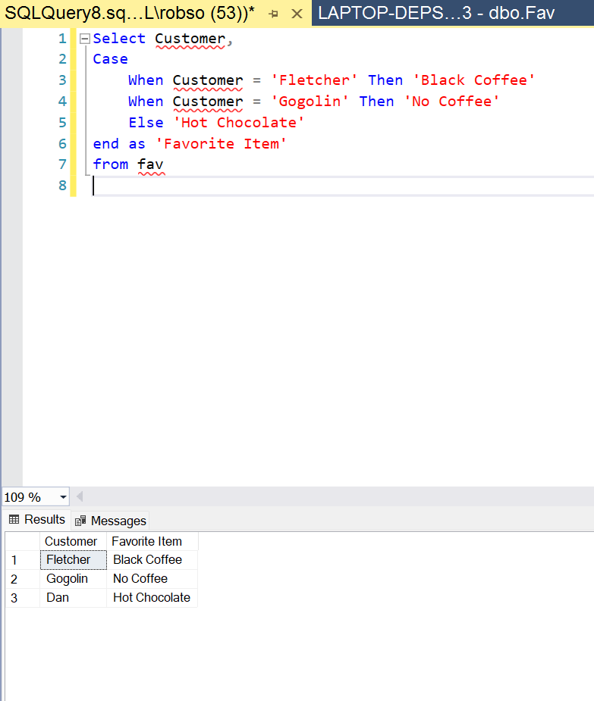
    1. Selects the Customer column
    2. When the customer is blank then ‘Favorite item’ will be blank
    3. End as ‘Favorite item’ to insert into that column
    4. From the fav table
11. 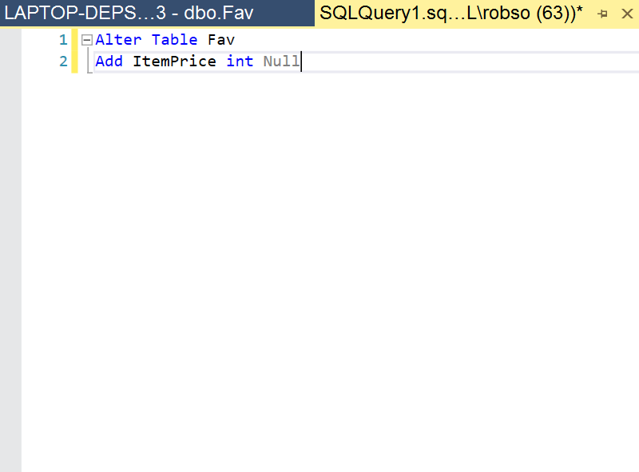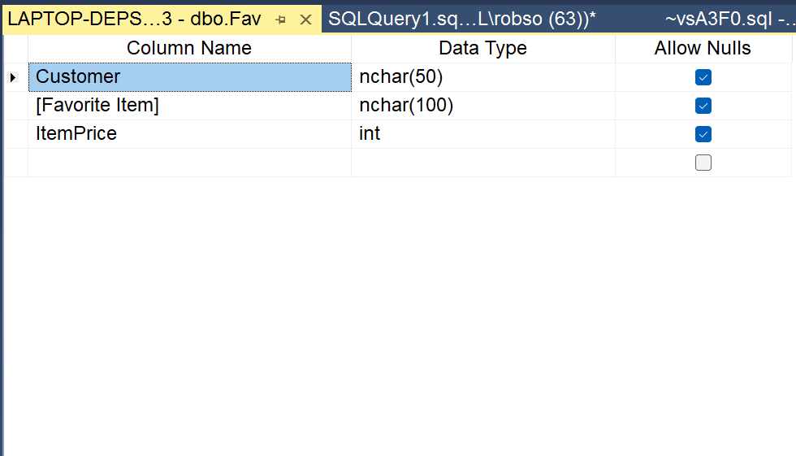
    1. Alters the Fav table
    2. Adds item price as an integer that is null
12. 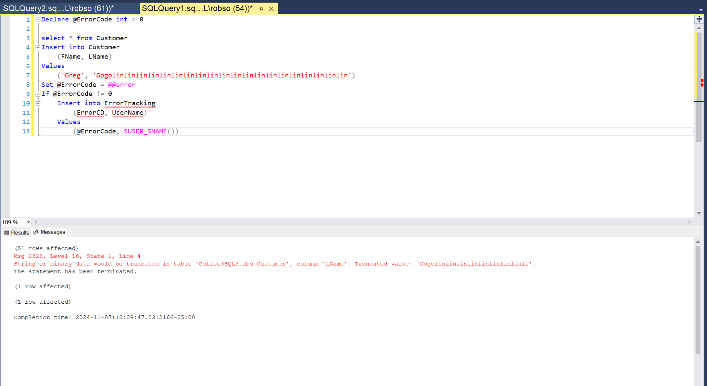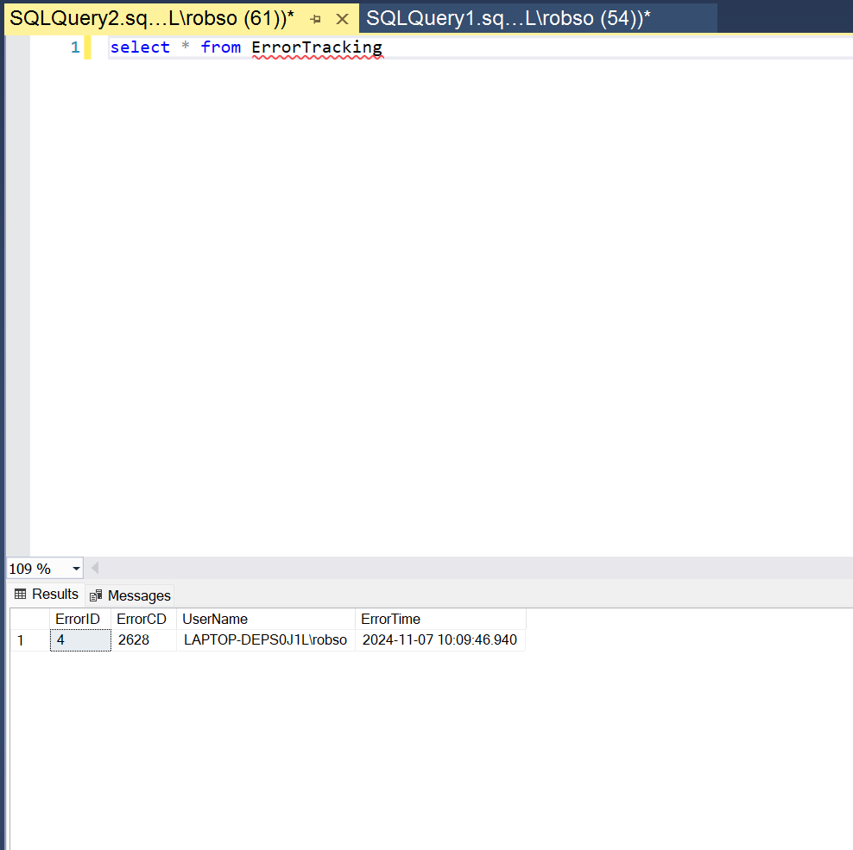
    1. Declares @errorcode as an int being 0
    2. Inserts FName and LName into customer
    3. The values we are inserting and creates an error
    4. Sets @ErrorCode to equal @@error so @@error does not reset after the new insert statement
    5. If @errorcode != meaning there is an error
    6. Insert into error tracking table
    7. Inserts the error code as @error code as well as user name
13. 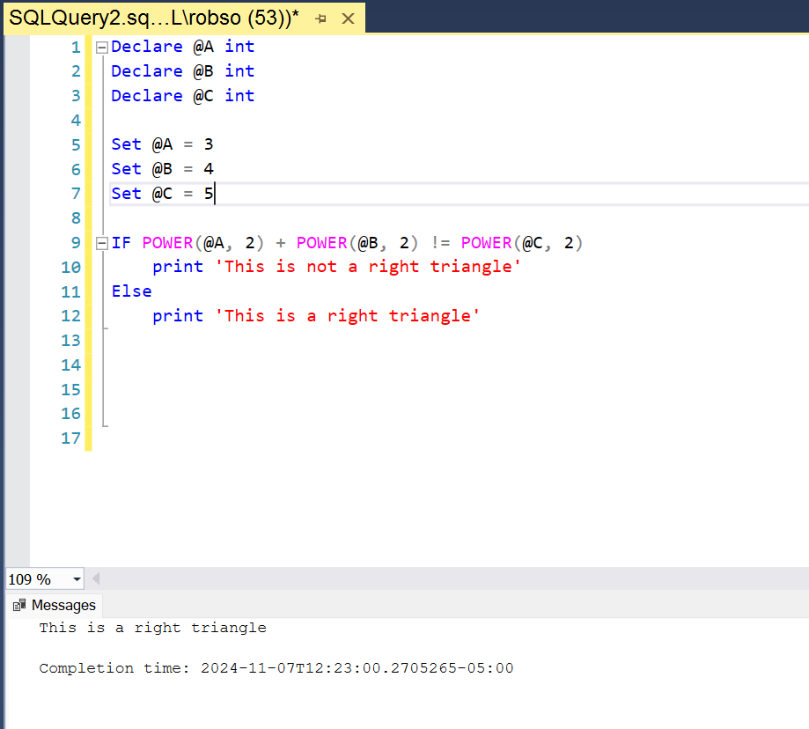
    1. Declares the variables
    2. Sets the variables
    3. If the pythagorean theorem does not work then its not a right triangle
    4. Vice Versa
14. 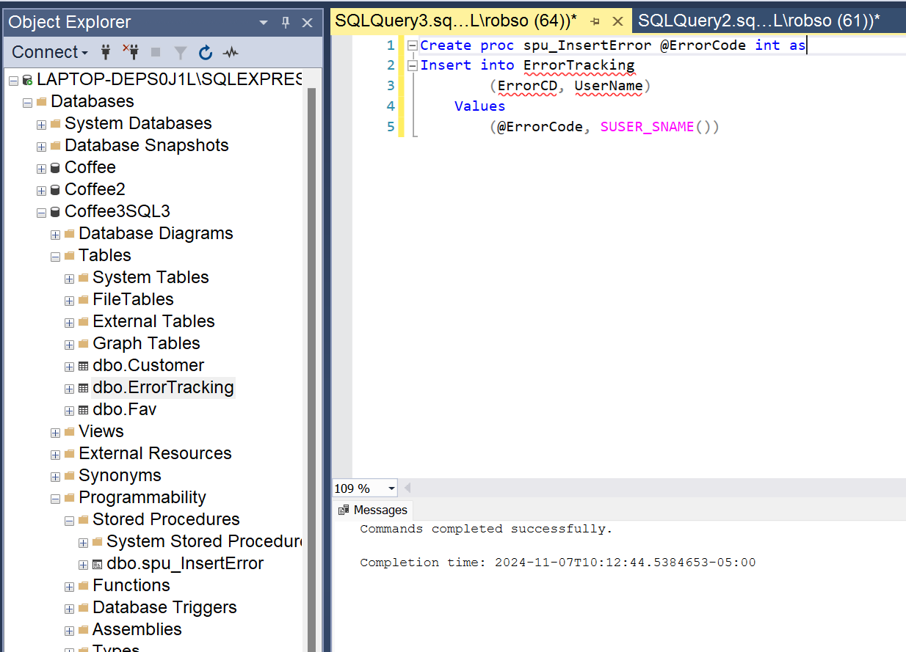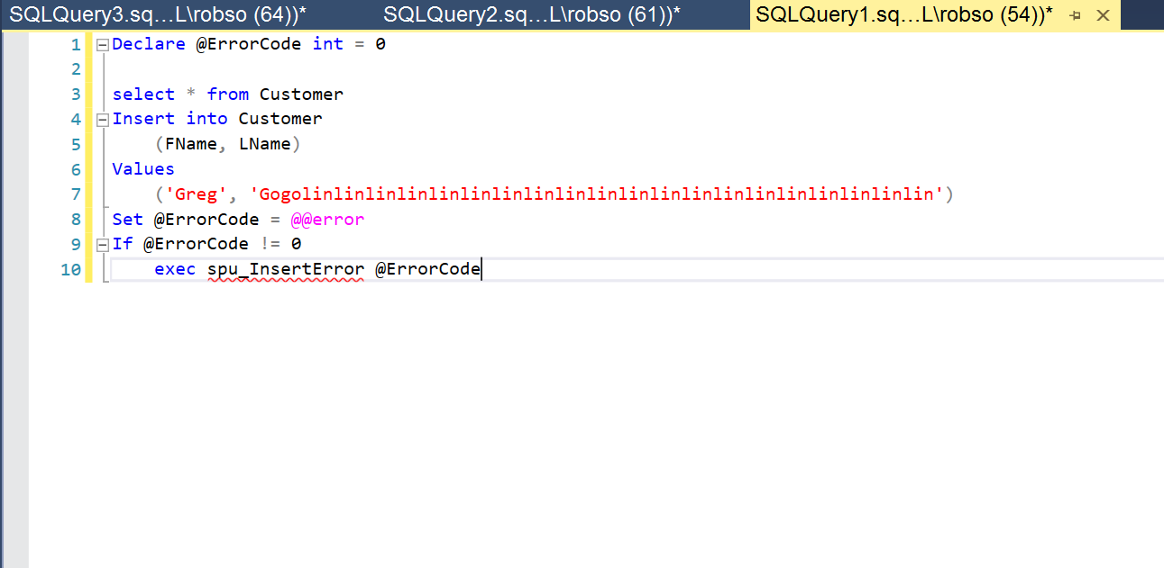
    1. Creates the Stored Procedure and requires @errorecode
    2. Where we are inserting to and what
       1. If the @errorcode != 0 then execute the stored procedure
15. 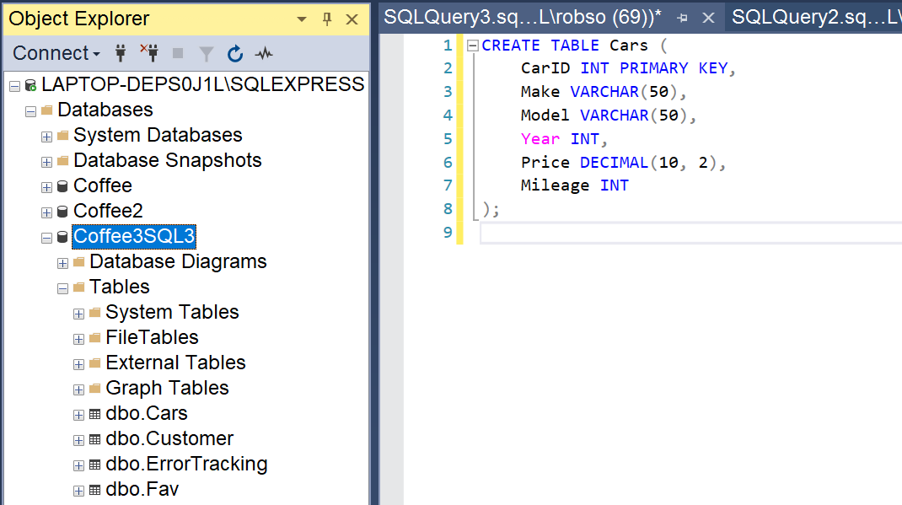
    1. Creates the car table
    2. 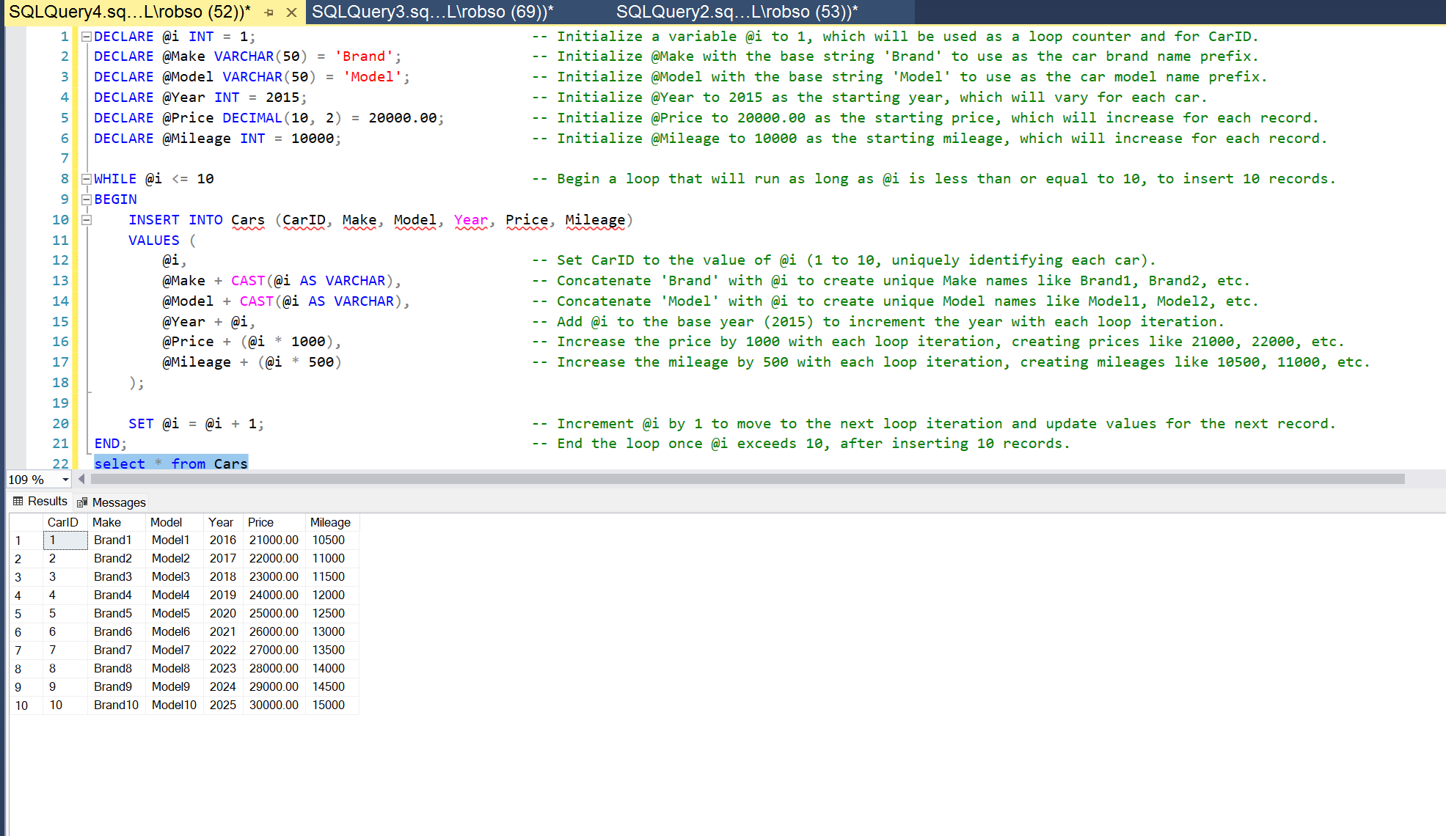
16. 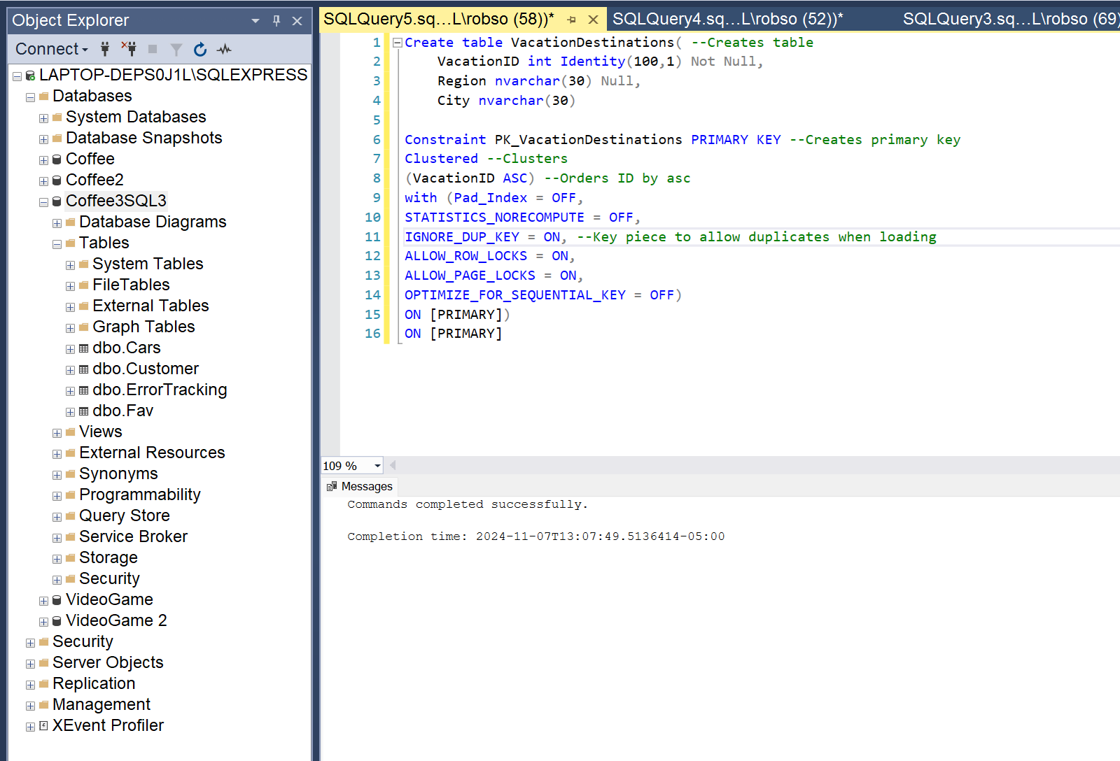
17. 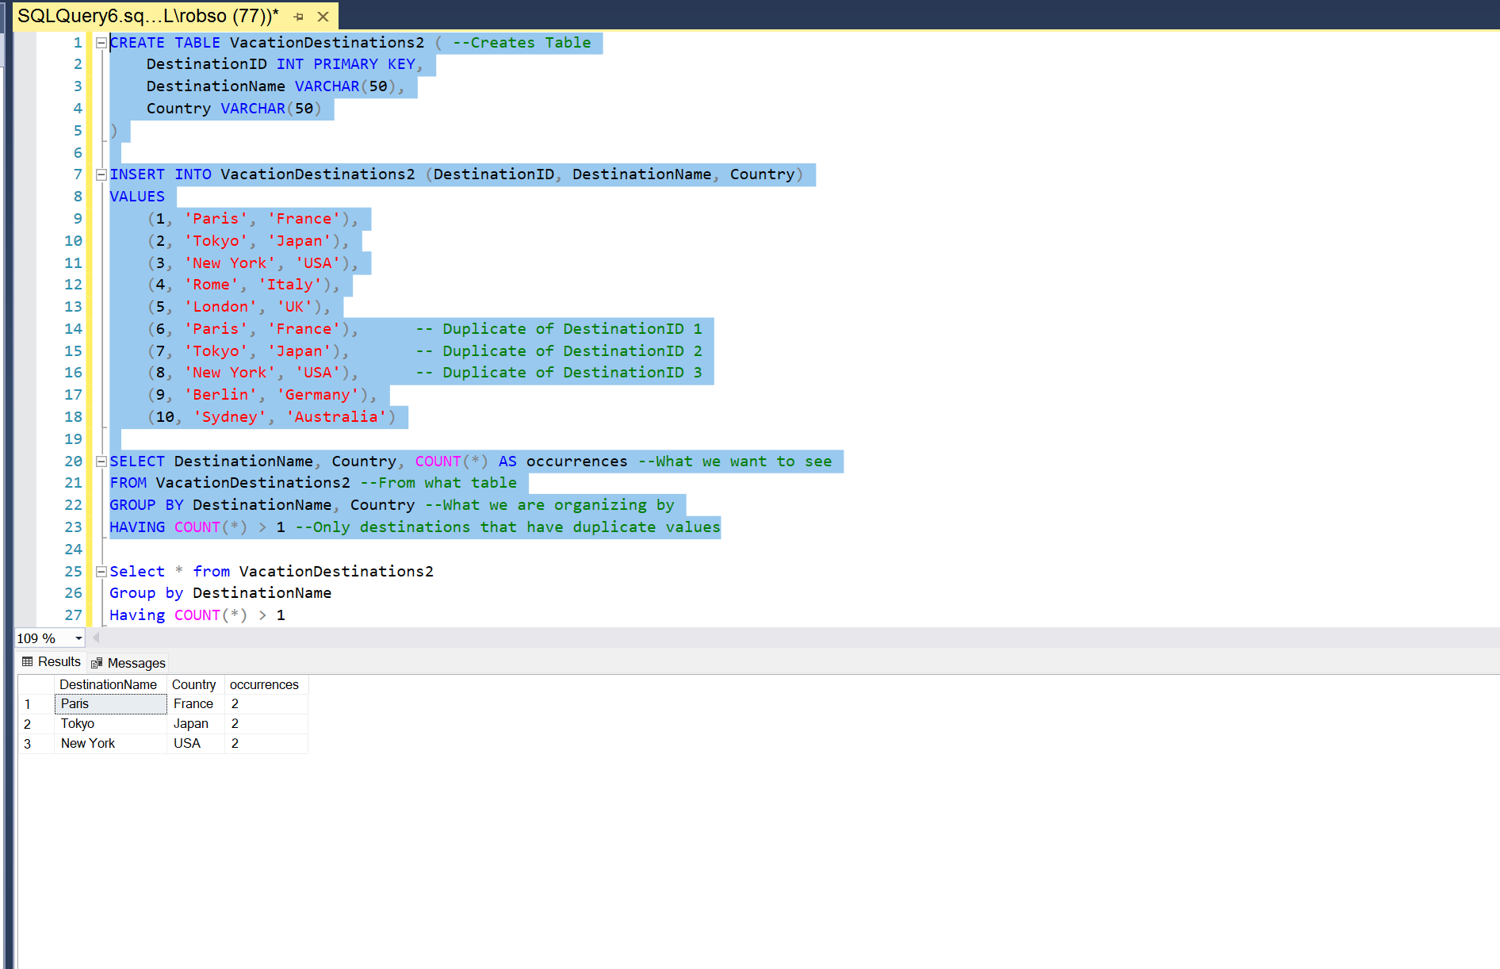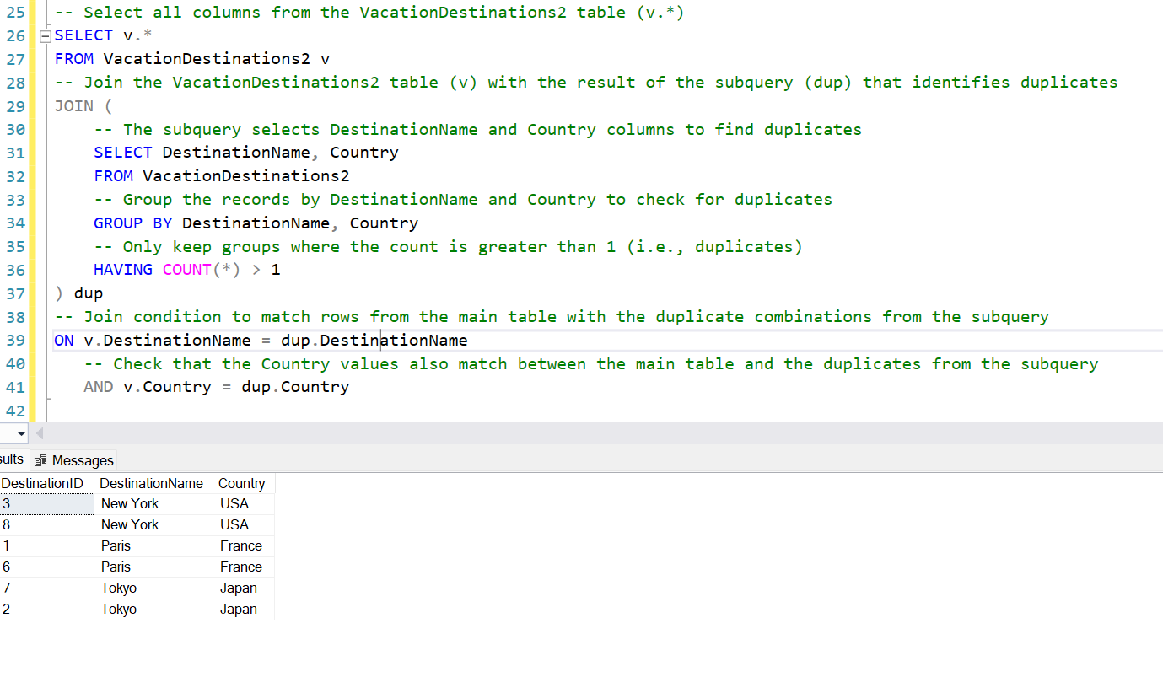
18. 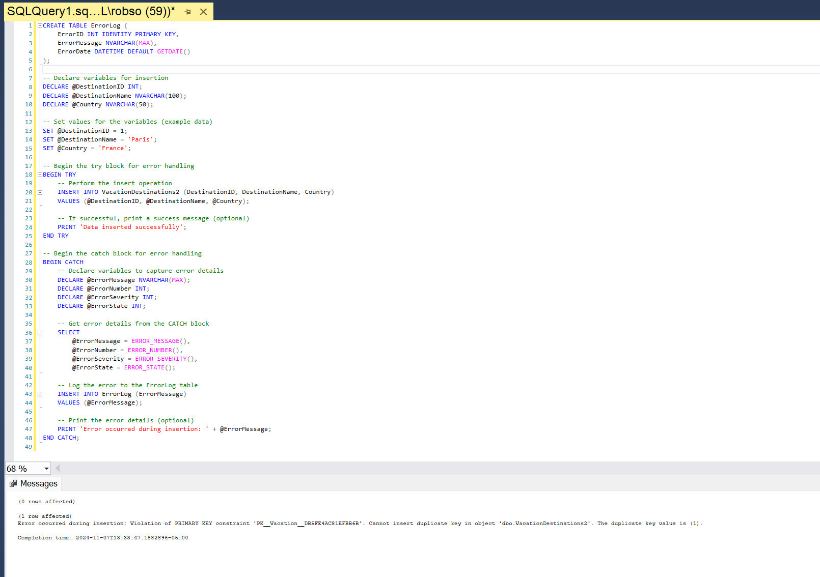

SQL Assignment 4

1. 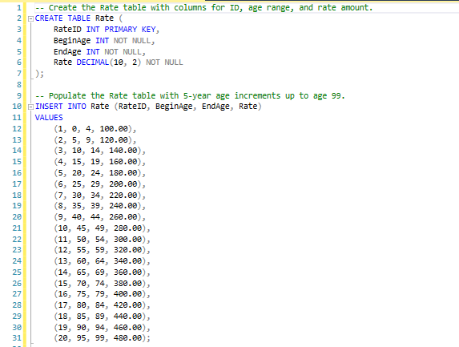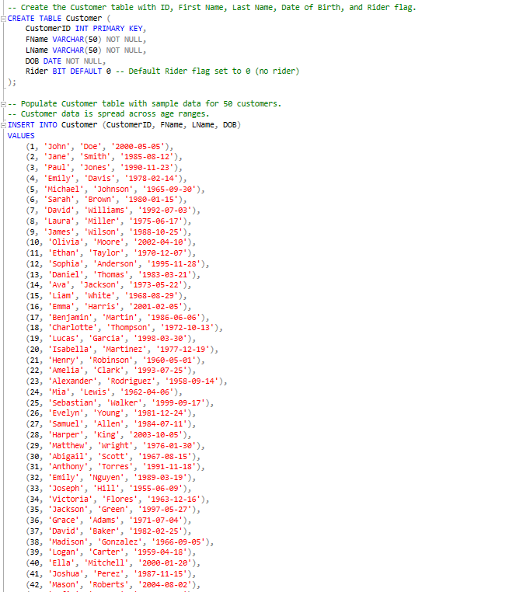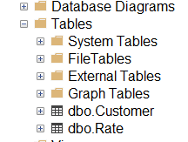
2. 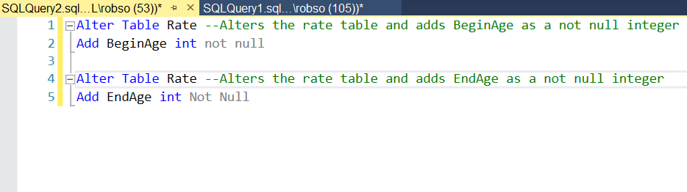
3. 